Prerequisites:

## Installing Git (version control system to get the files) - Go to <https://git-scm.com/> - Download the latest version:

* Go to the place where you want to install it and create a folder named “git”  
  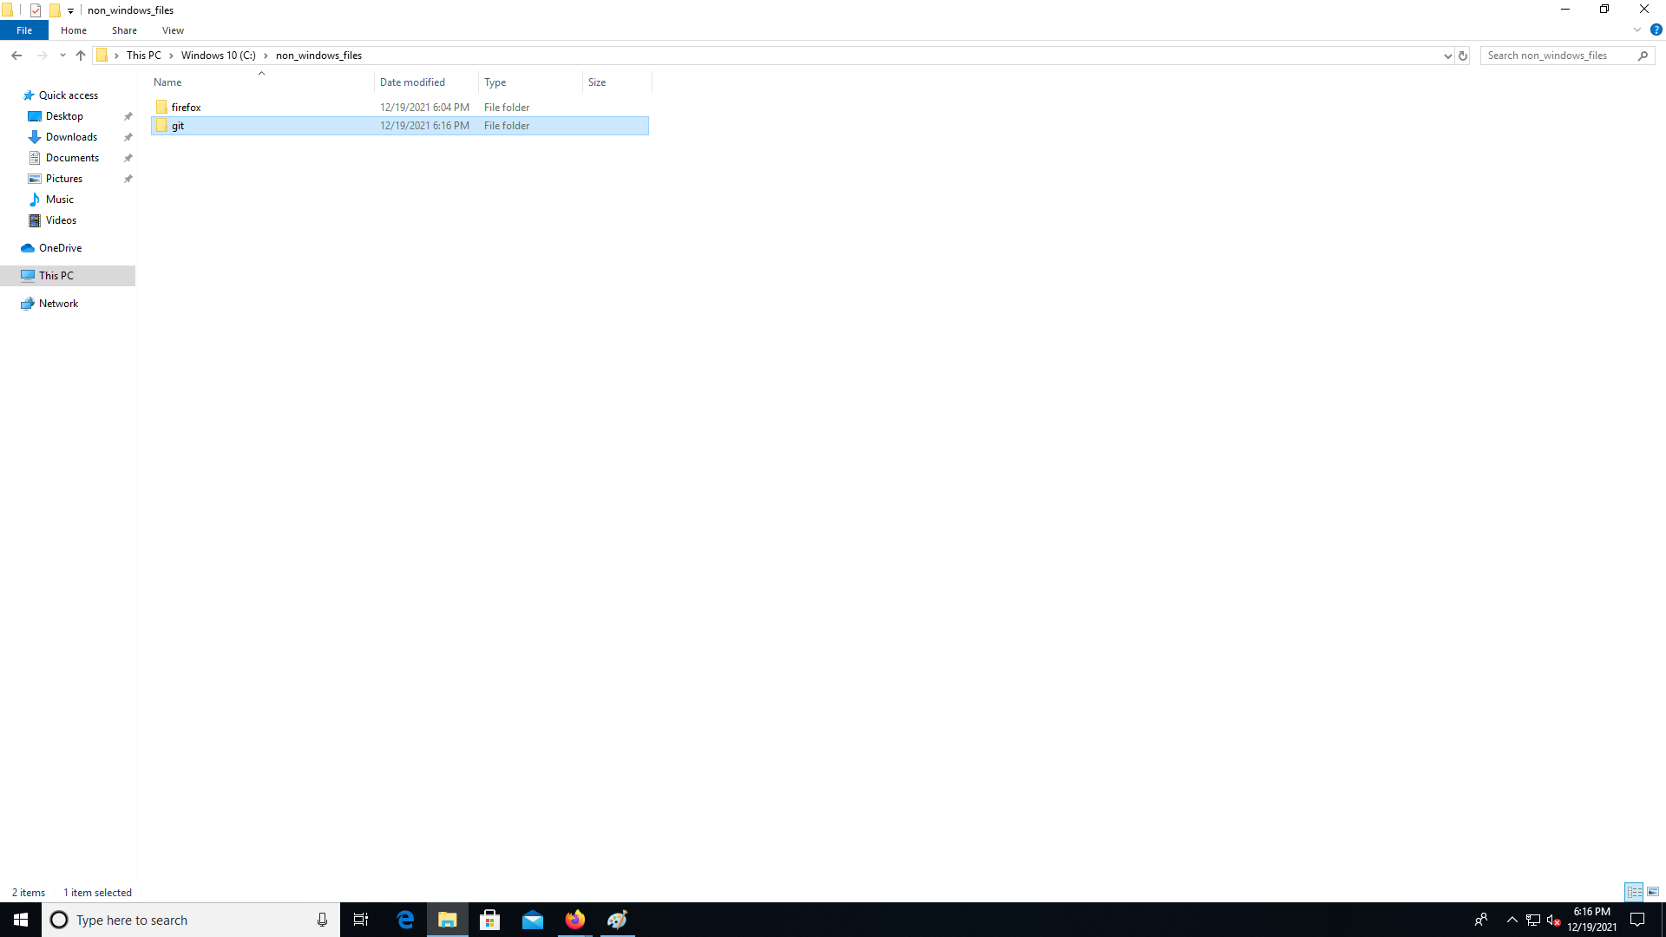
* Save the installation file:  
  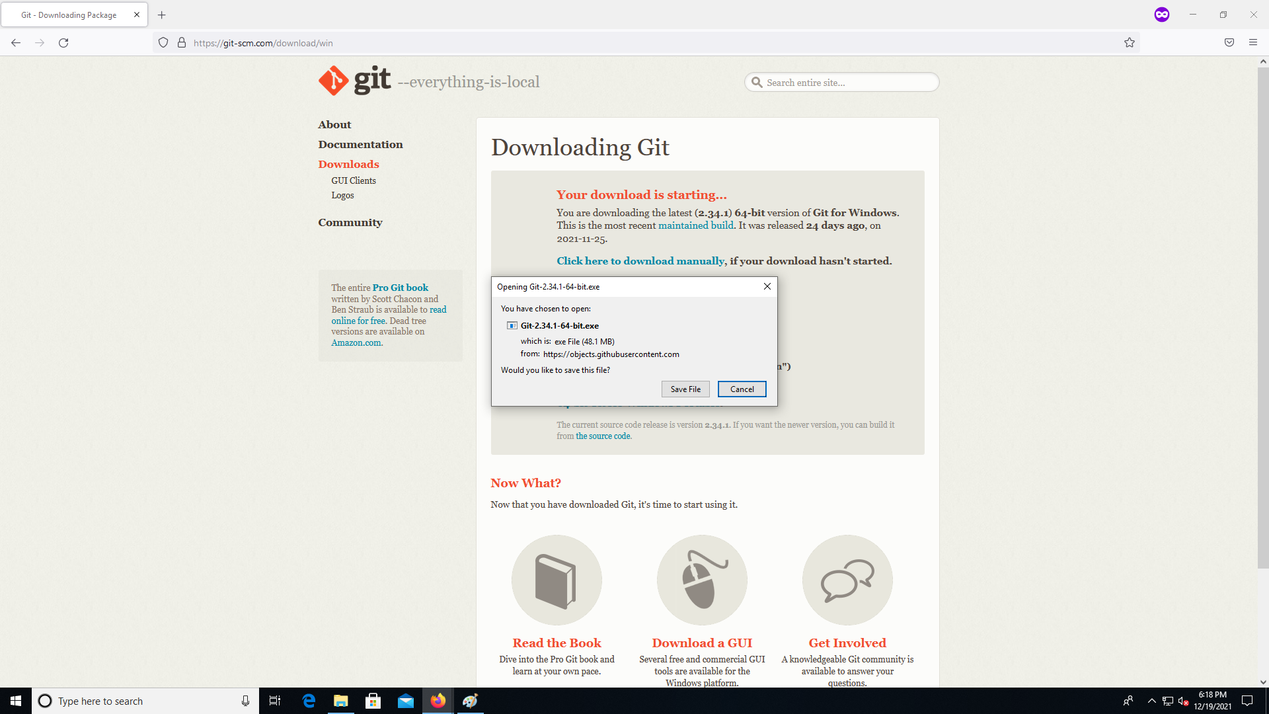
* Double click the installation file:  
  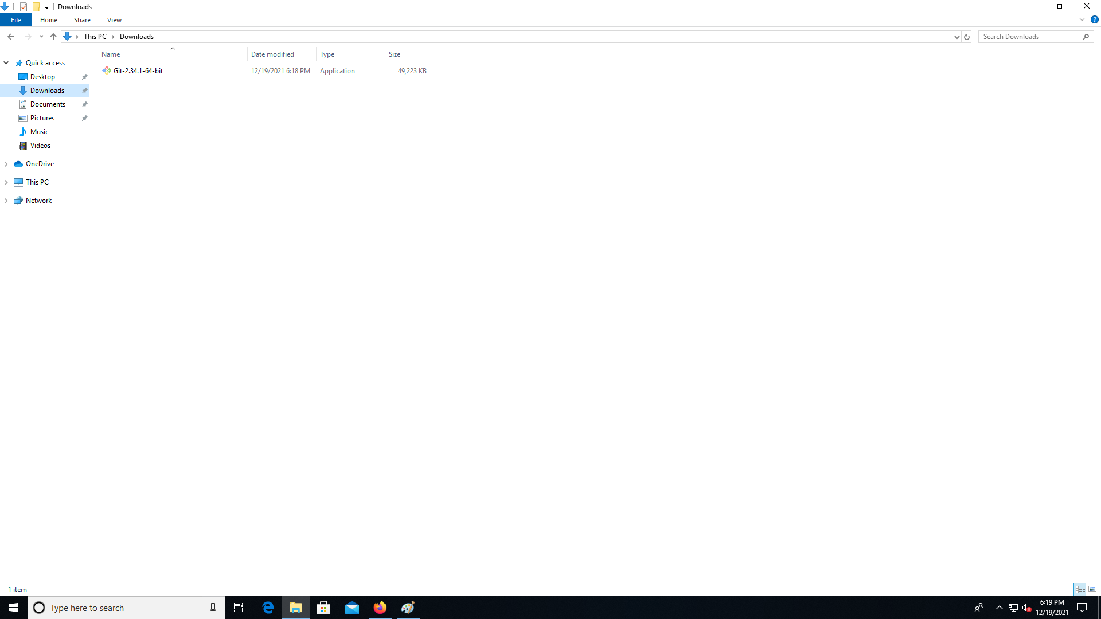
* Choose the git folder you created earlier as a place to install Git.  
  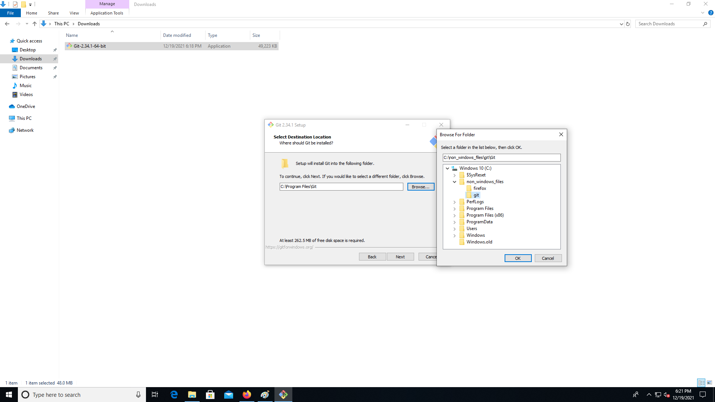
* Select the following options  
  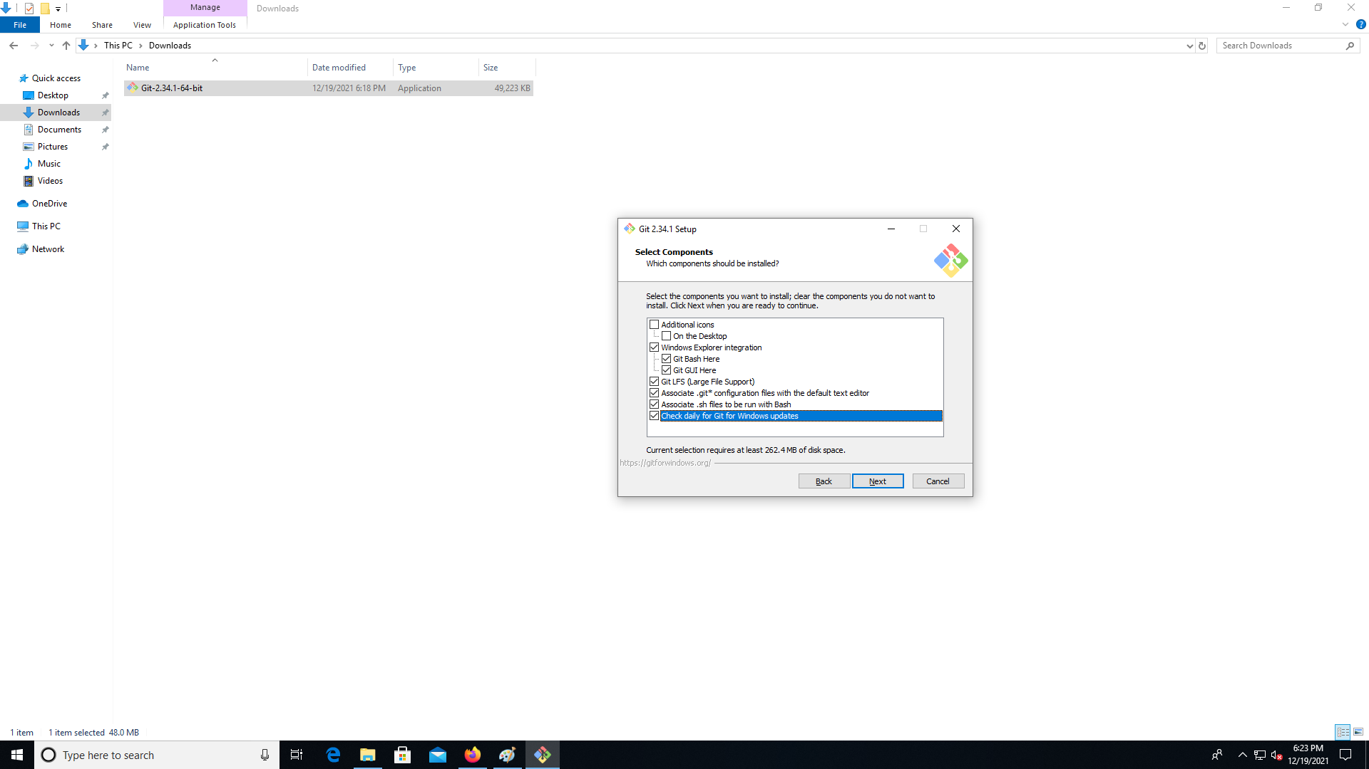
* Change the default editor to Notepad:  
  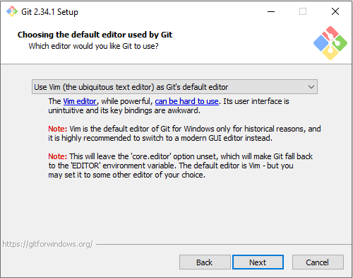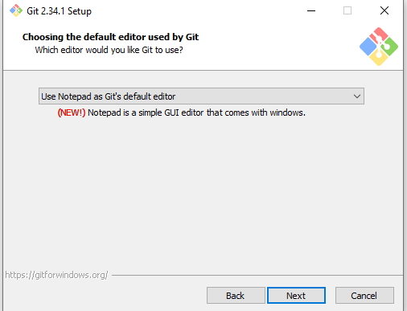

Click “Next” to the end then “Install” with the default options and wait for installation:  
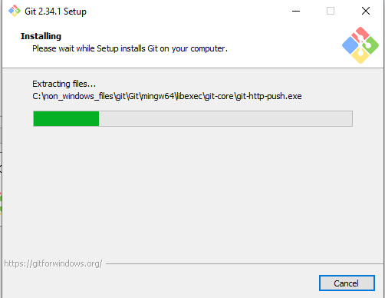

Click “Finish”, a web page with the latest release notes may be opened, you can close it.  
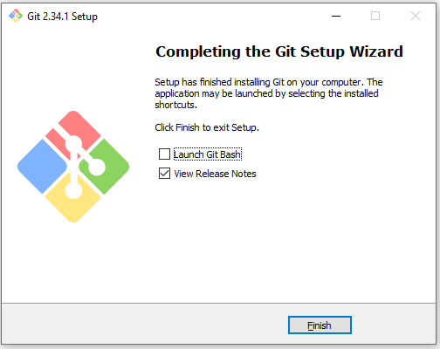

How to check if it works?  
When you right click you should see 2 new options:  
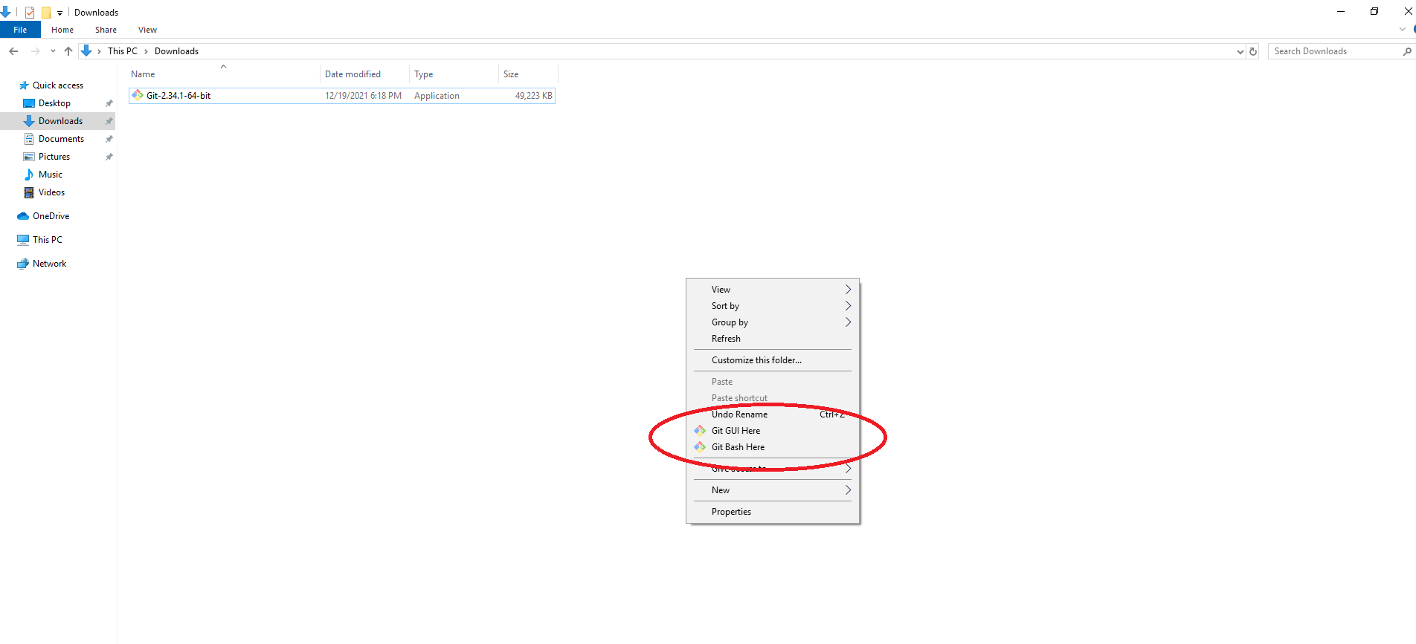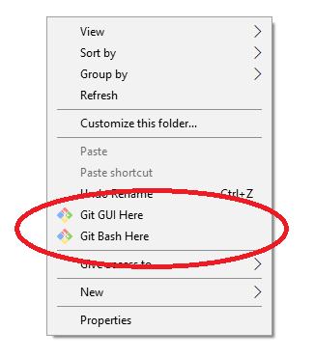  
click “Git Bash Here”:  
You will see a terminal similar to this one:  
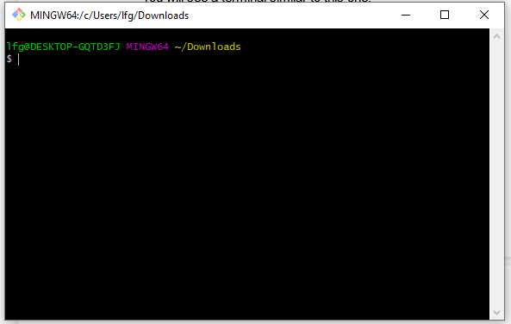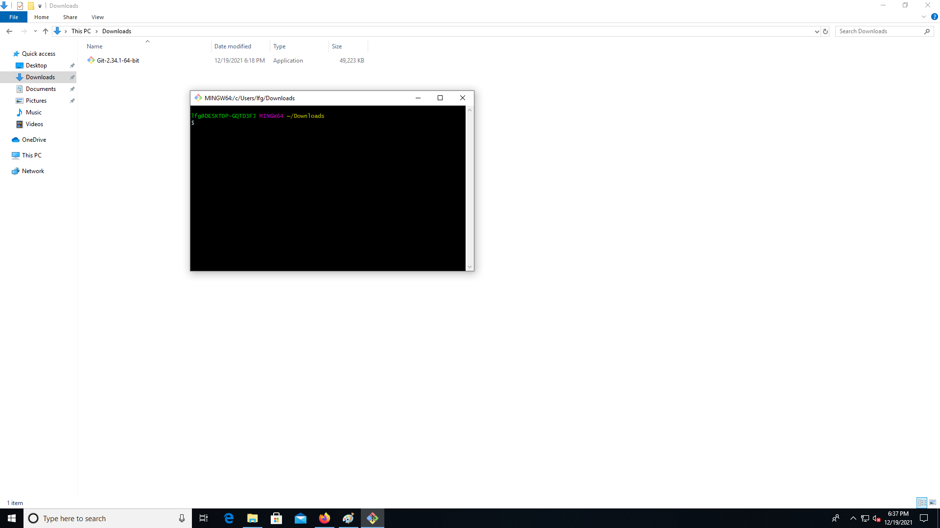

Type in “git –version”  
You should see output similar to this one (with different number, depending on when you have installed it, the latest version at the time of writing is 2.34.1)  
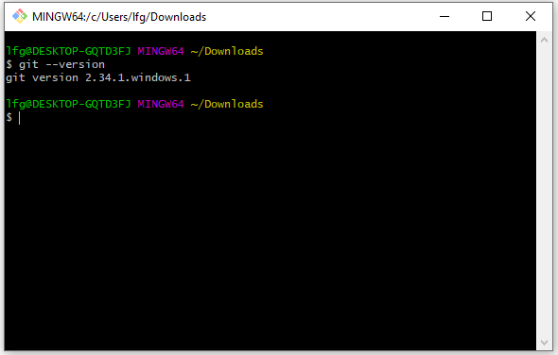

Now you can delete the installer file from your “Downloads” folder.

## Node.js and npm, what we will be using to run the bot.

* Go to: <https://github.com/coreybutler/nvm-windows/releases>, scroll down to this section:  
  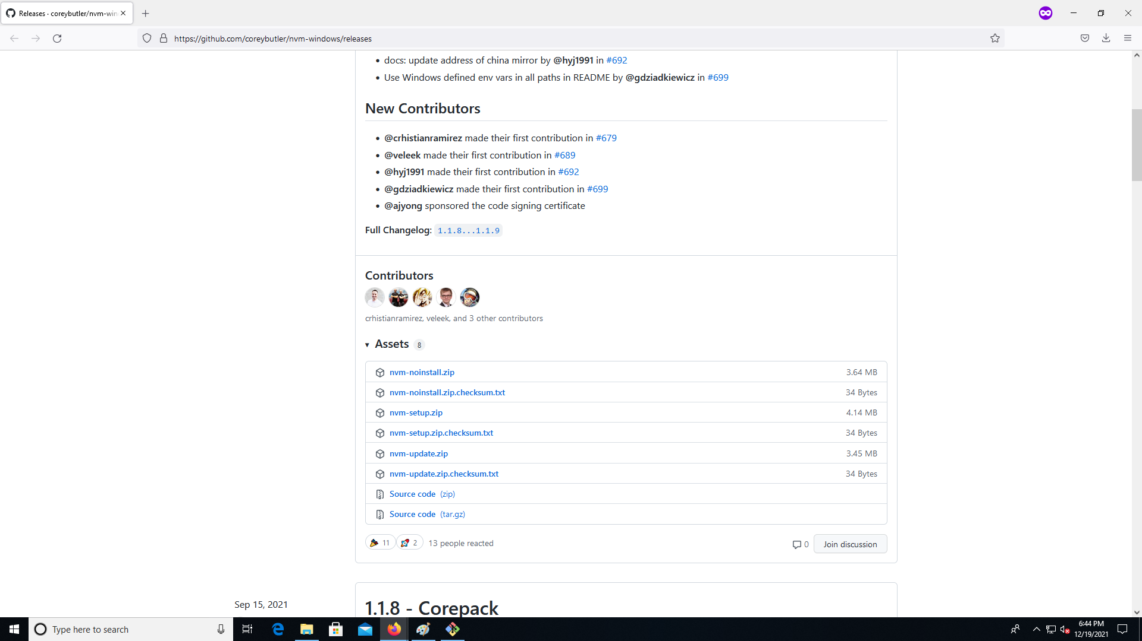

Click and download “nvm-setup.zip”:  
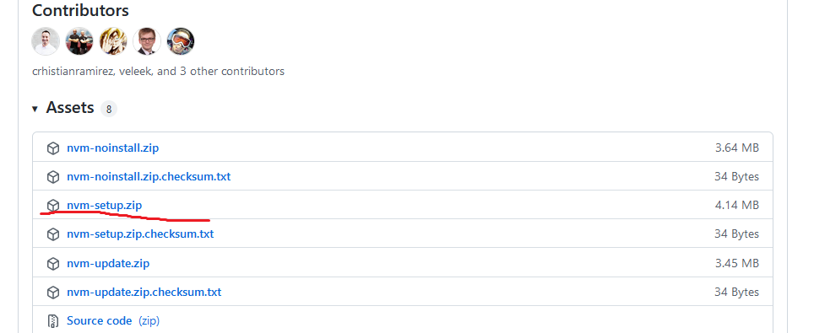

Save it:  
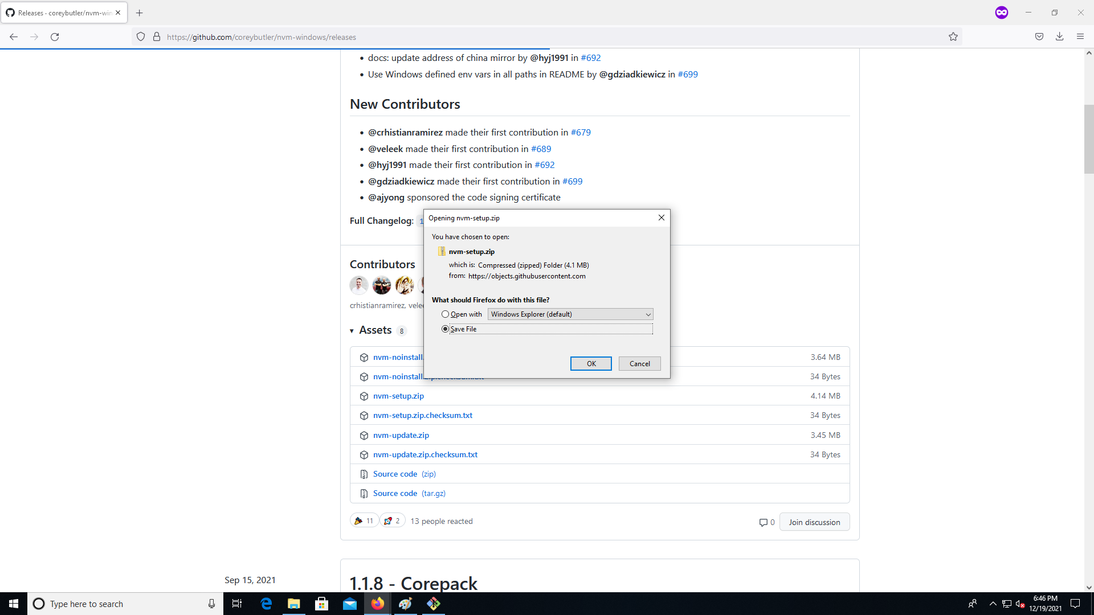

Go to your Downloads and right click the file:  
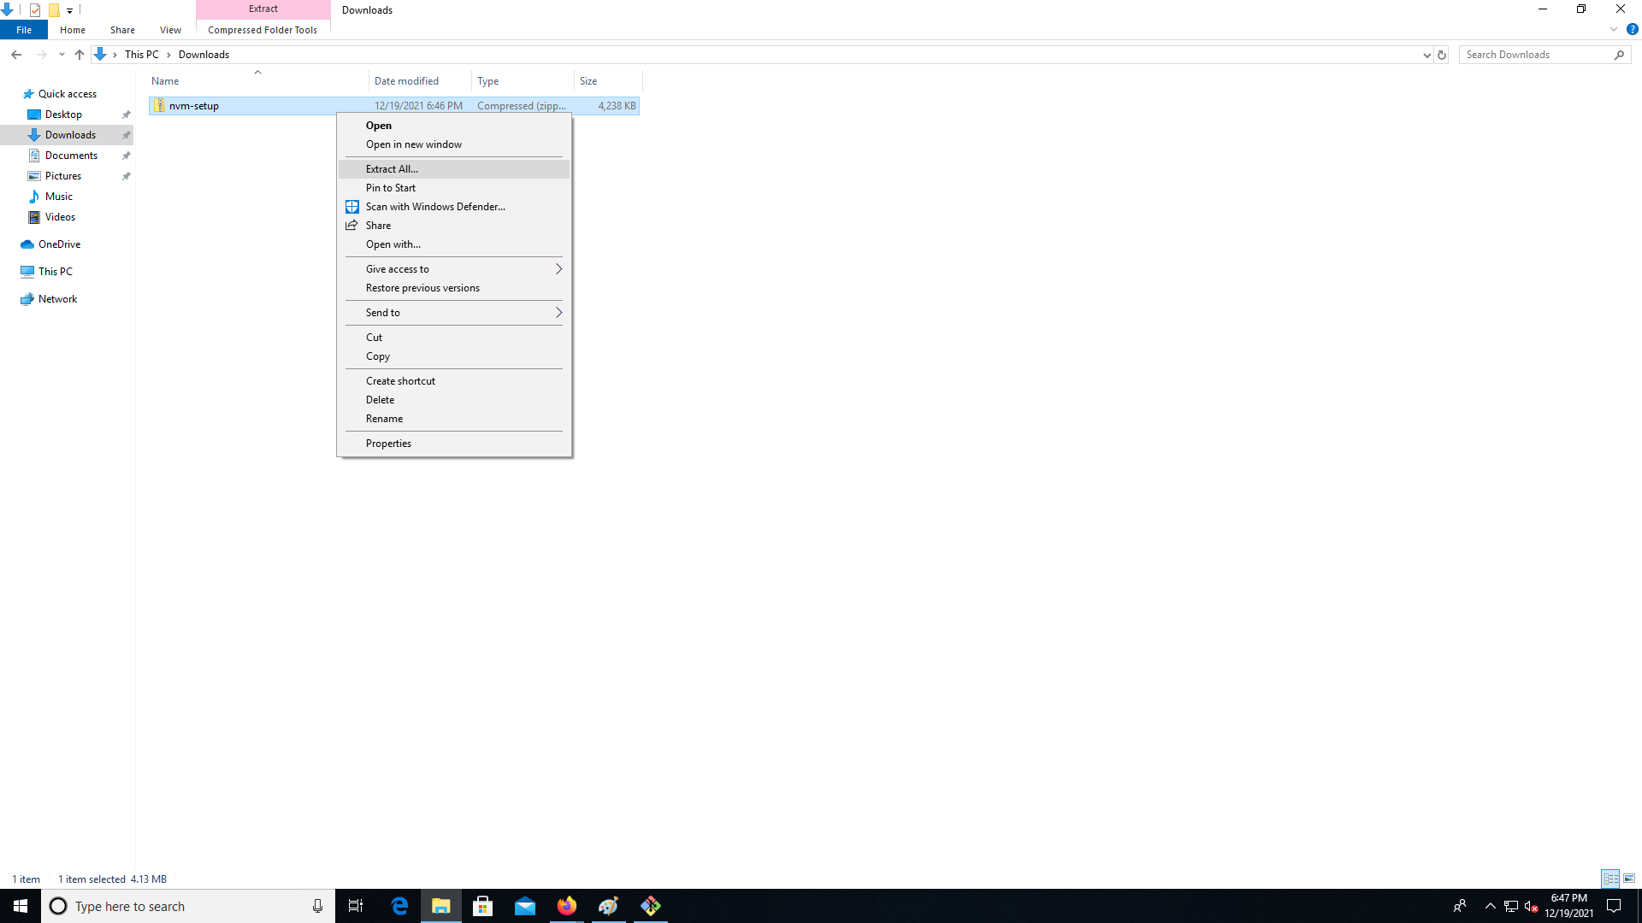  
Click “Extract all” (or otherwise extract the file with a program like 7zip, available here <https://www.7-zip.org>/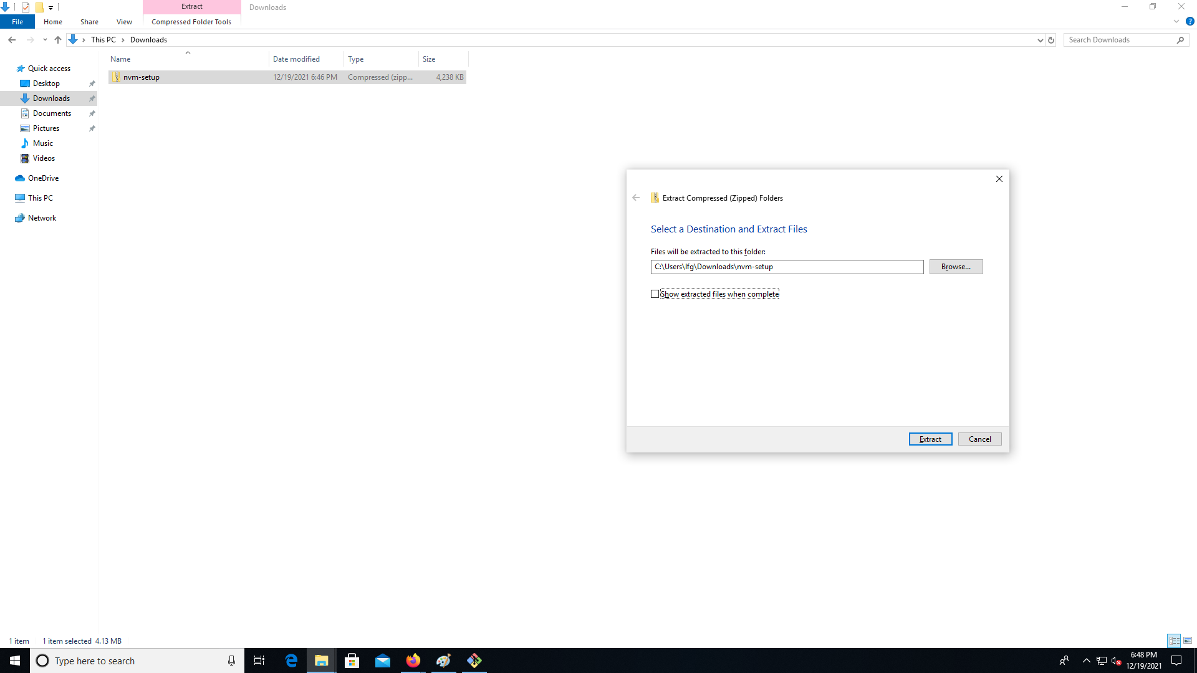

Click “Extract”.  
  
Go to the “nvm-setup” folder:  
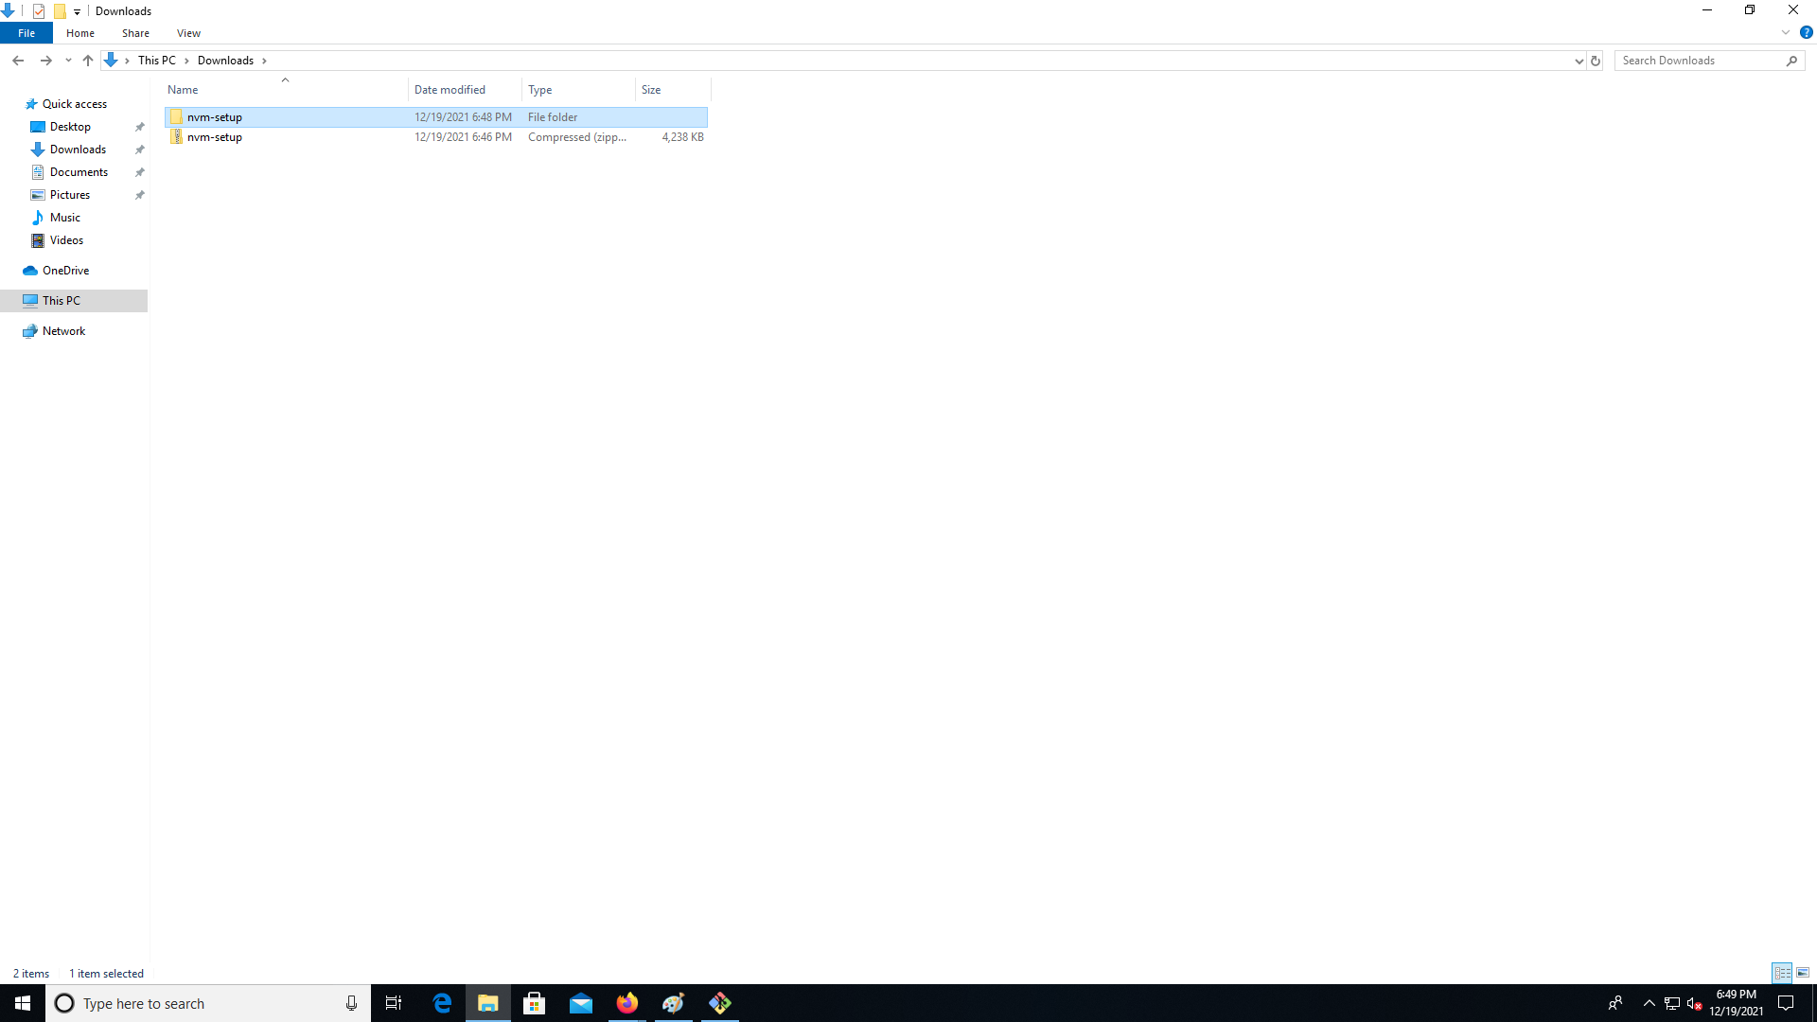

Double click the file called “nvm-setup”:  
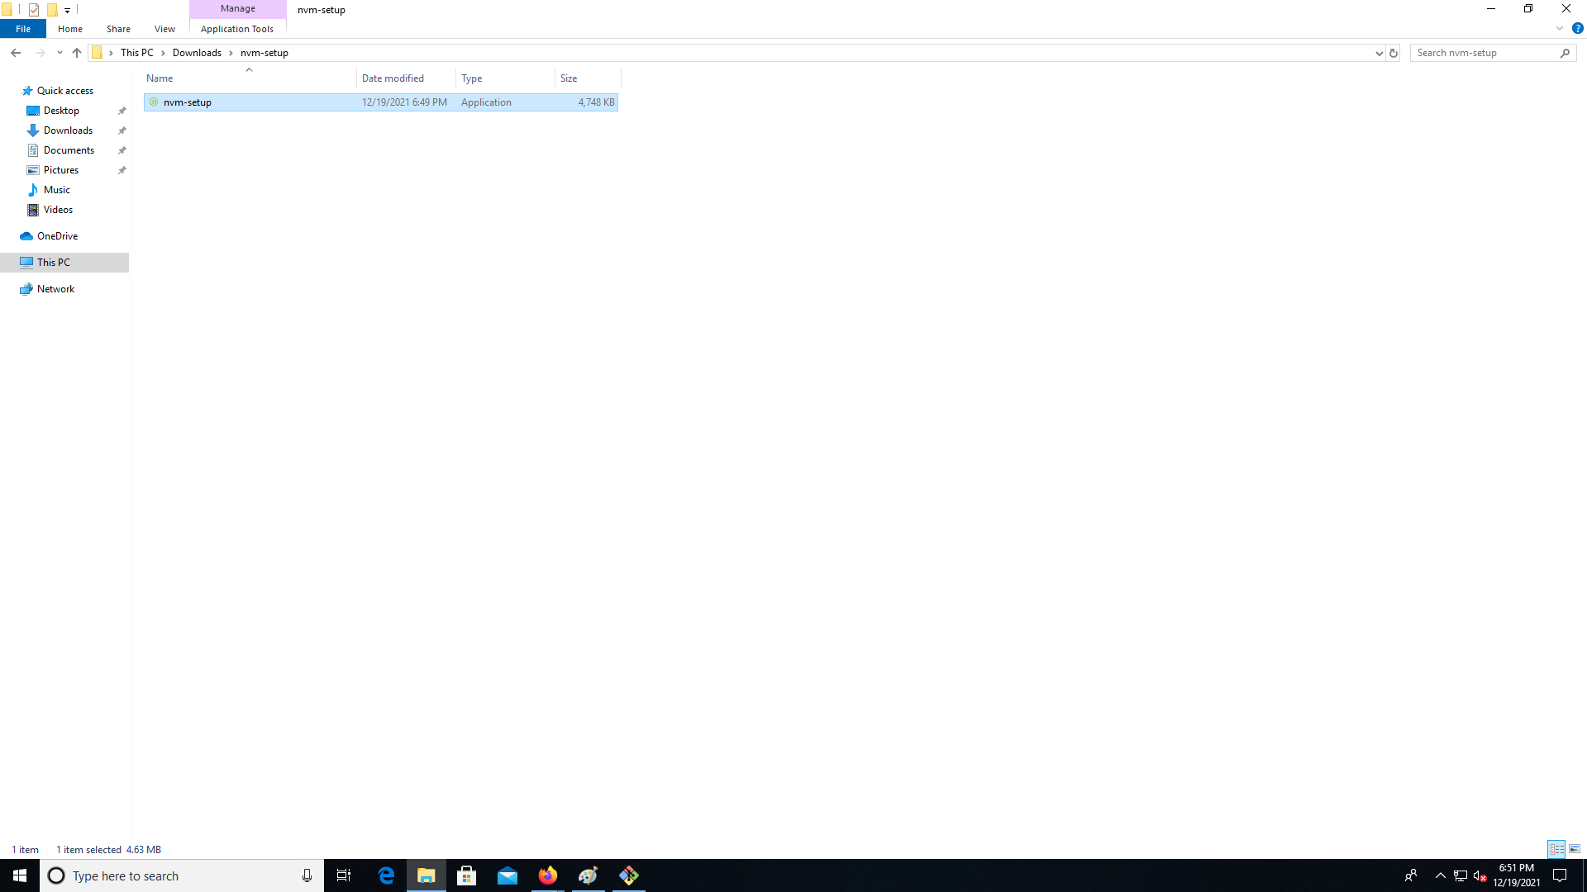

Then right click it and press “Run as an administrator” (we need the elevated privileges so we can access Node.js from anywhere):

Read and agree to the terms, click “Next”  
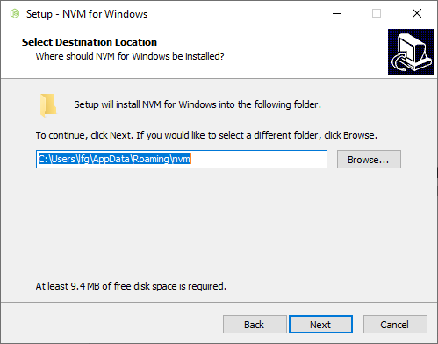

On the next step click “Next”:

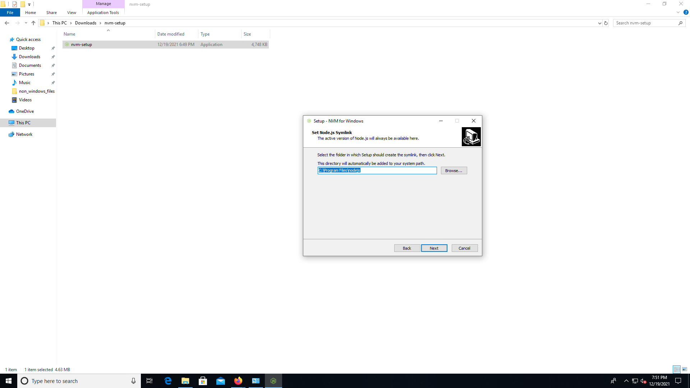  
  
  
Click “Install”:

Right click and press “Git Bash Here” as in the check with “Git”.

Type in “nvm”:  
  
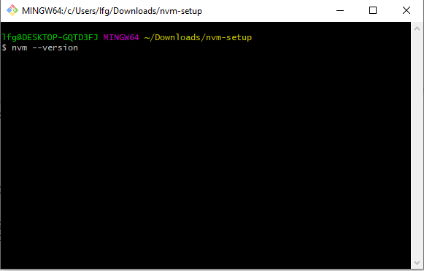

You should see an output like this one:  
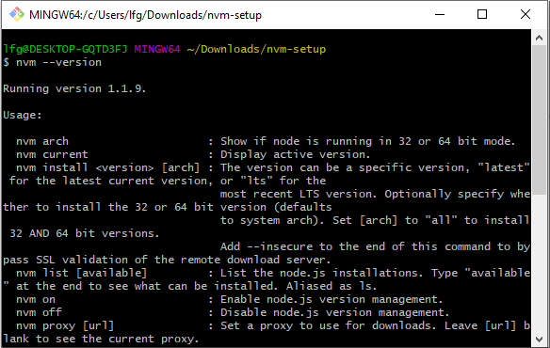

Type in “nvm install latest:  
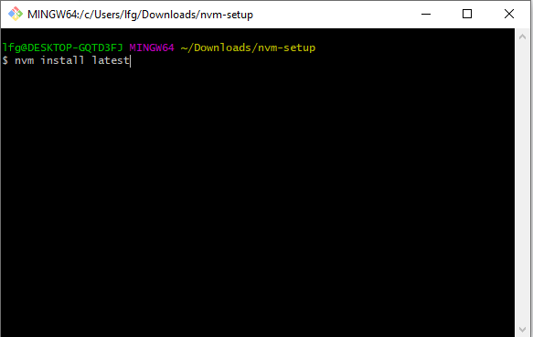

Wait for it to load.  
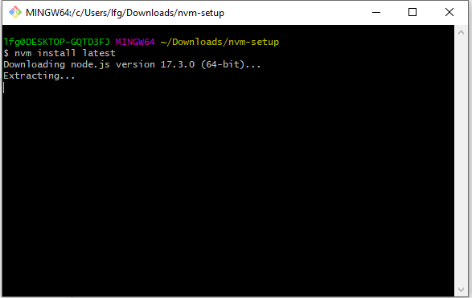

When it is ready, you should see:  
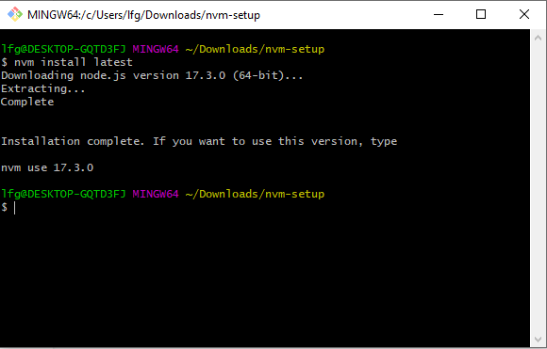  
  
Close this window. Then click the windows button:

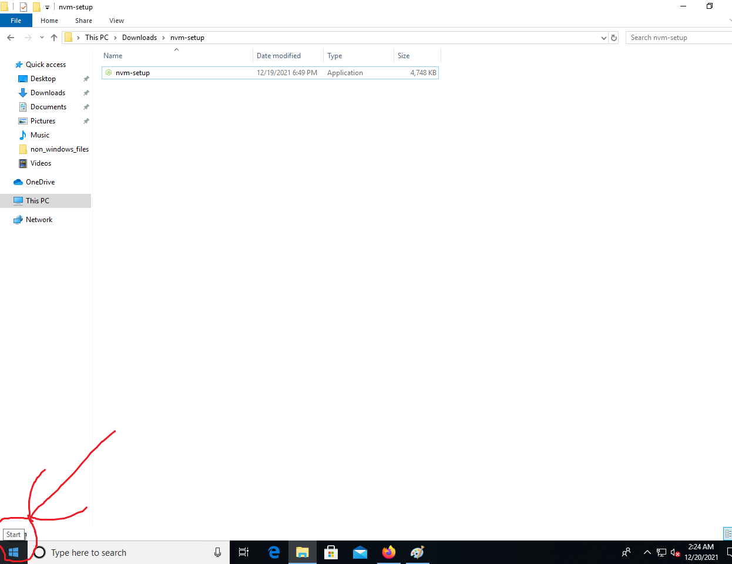

Typ in “cmd”, you should see the following icon:  
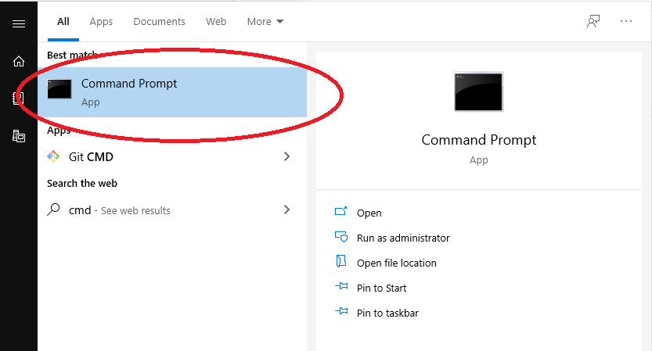

right click it and press “Run as administrator”:  
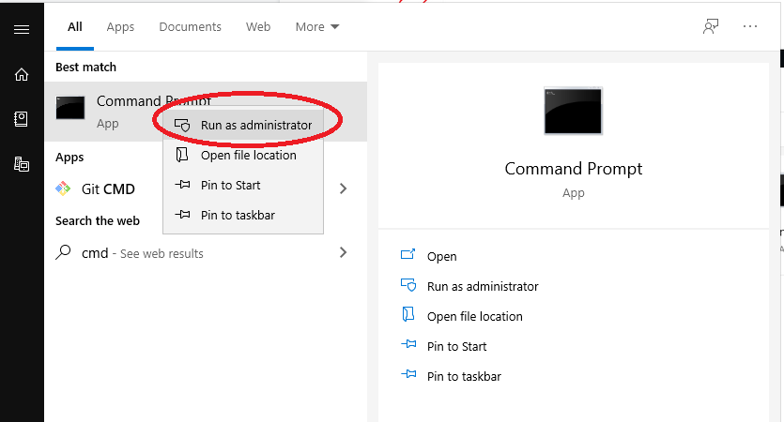

Type in “nvm use 17.3.0” (or replace with the version number you saw in the above pictures)

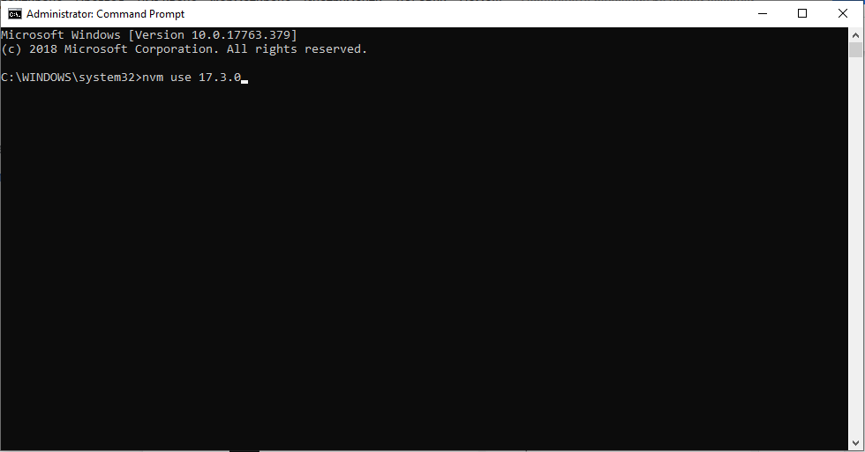  
  
You should see:  
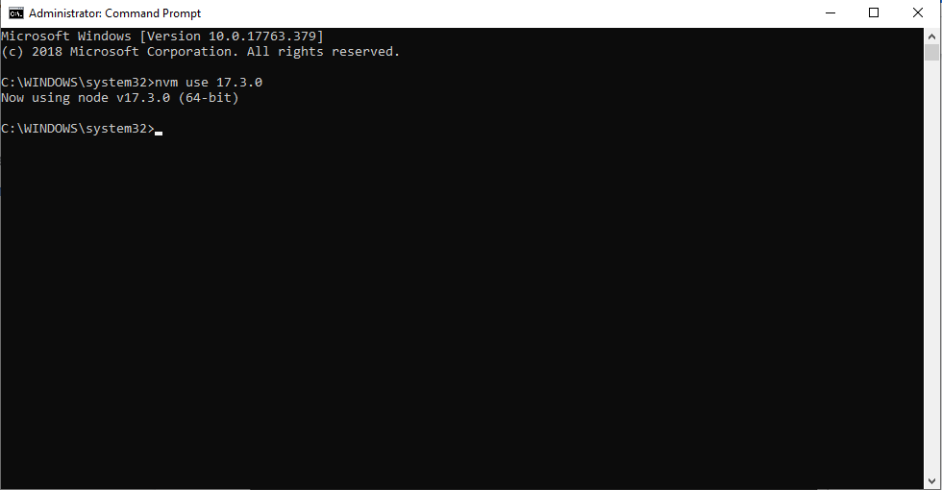

Right click and press “Git Bash Here” (anywhere) and see similar terminal:  
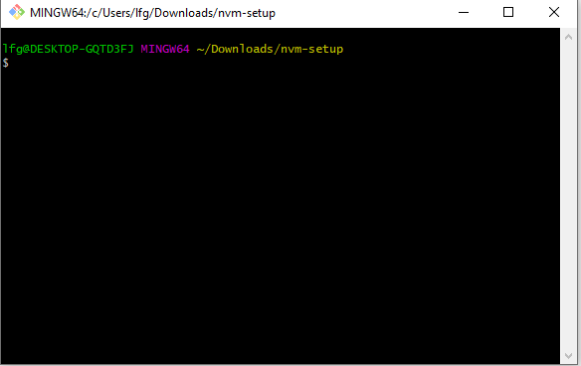

type in “npm –version”

then “node –version”

You should see:  
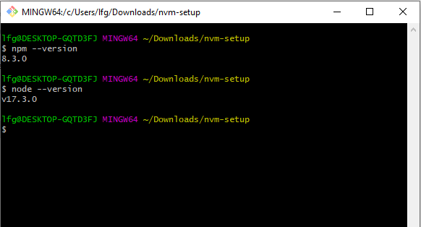

Close this window, now we have Git, NPM and Node js installed.

### Version notes - the bot has been developed on Node js version 17.1.0 and works with version above 16. As 16 is the latest stable version I didn’t see the need to write this guide for further in the future.

## Getting the bot’s files:

## 

Go to a directory where you want to setup the bot

Right click and click “Git Bash Here”:  
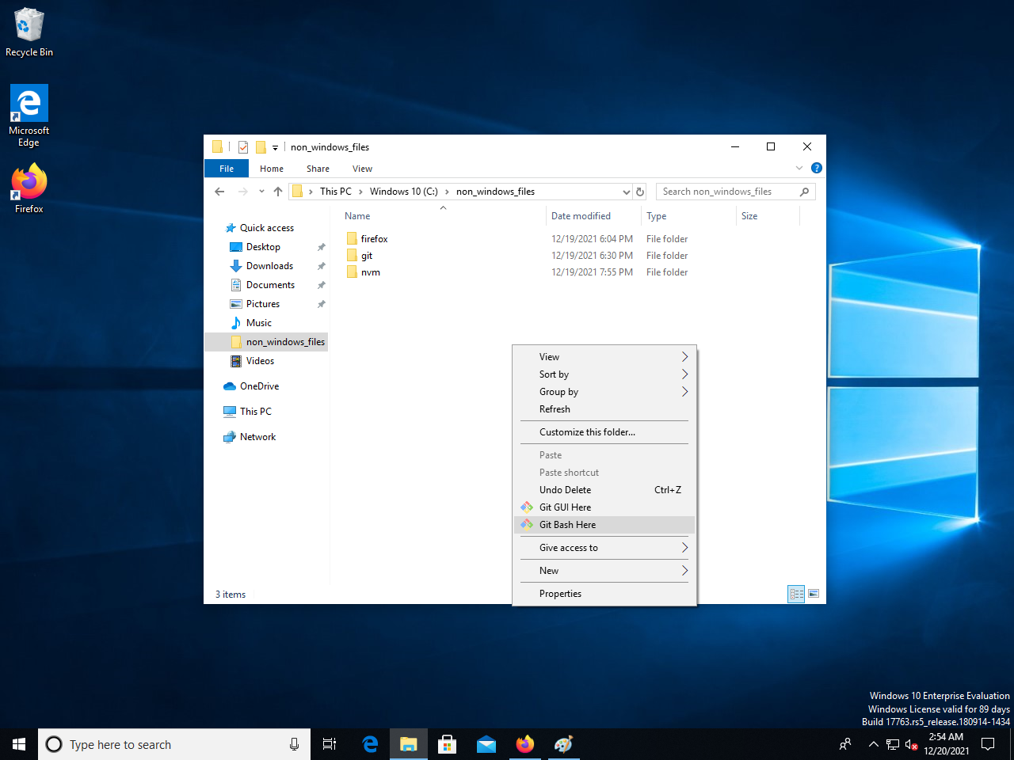

type in (or copy and paste in):

git clone https://github.com/vikito755/discord-find-games-bot.git

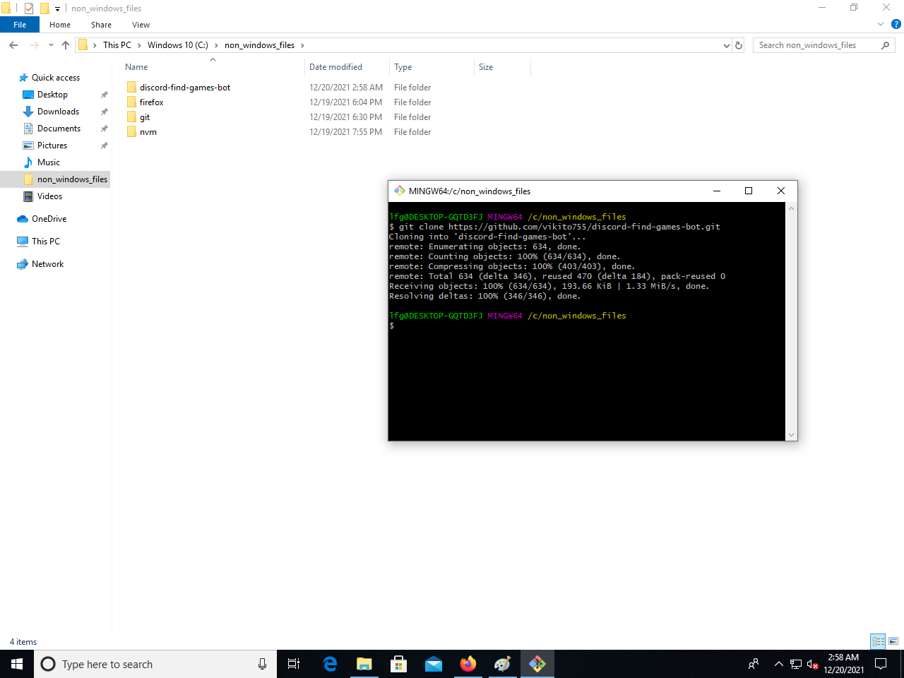

You should see a new folder called “discord-find-games-bot”.  
  
close the terminal (where you wrote git clone <https://github.com/vikito755/discord-find-games-bot.git>):

## Setting up Discord developer portal settings:

## security notice DO NOT REVEAL YOUR SECRET KEYS, TOKENS OR IDs, think of them like passwords, the keys shown here are deleted immediatealy after the publishing of this tutorial.

## 

Go to: <https://discord.com/login?redirect_to=%2Fdevelopers%2Fapplications>  
  
Then login with Discord.  
  
If you get logged in as usual type in:  
<https://discord.com/developers/applications>

You should see:  
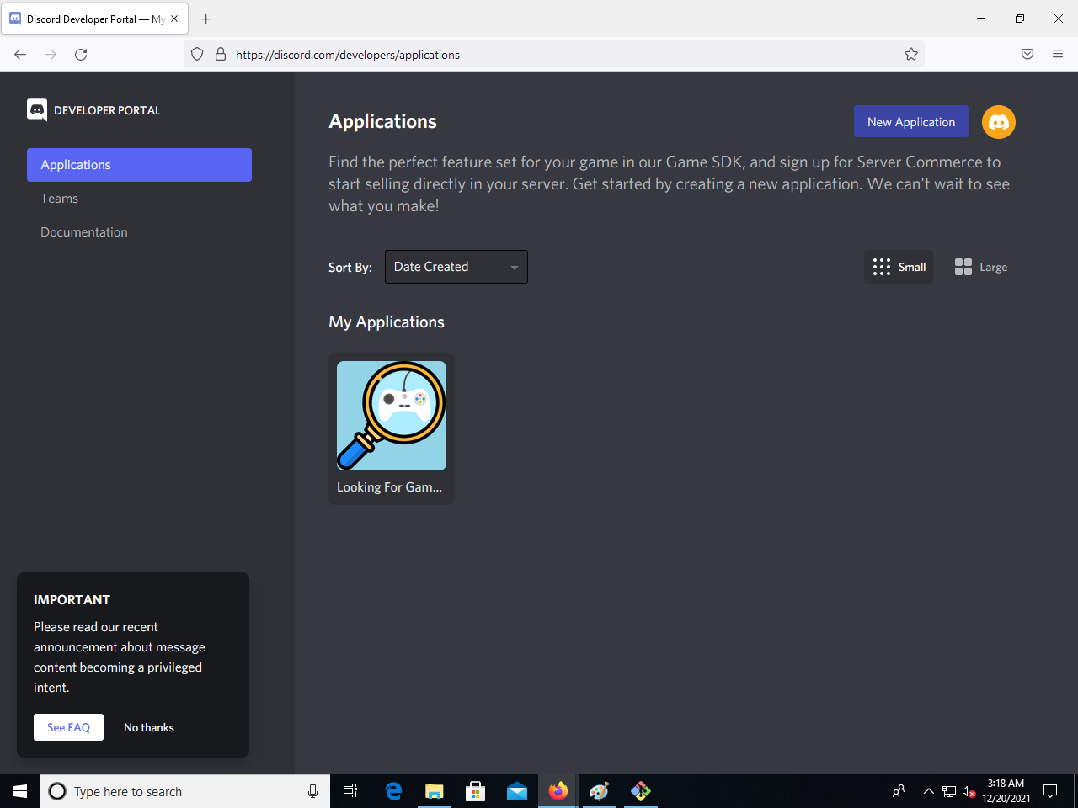  
  
Click “New Application”

Name the bot and you should see something like this:  
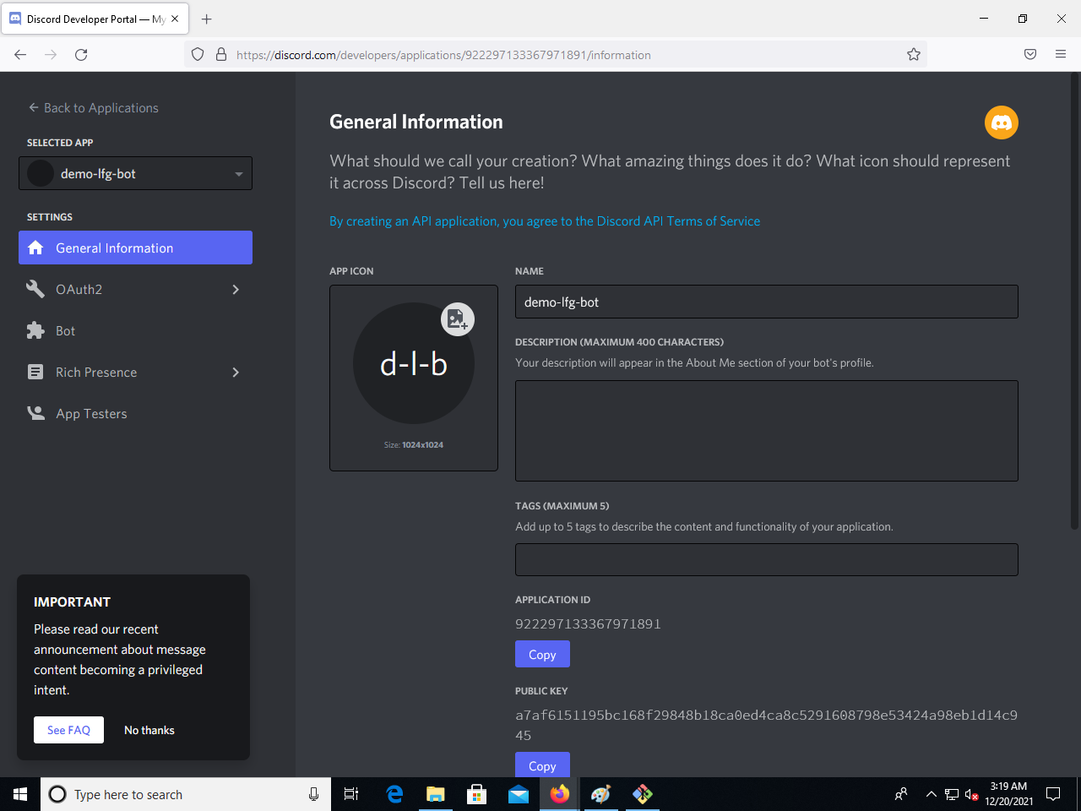

Go back to your folders:  
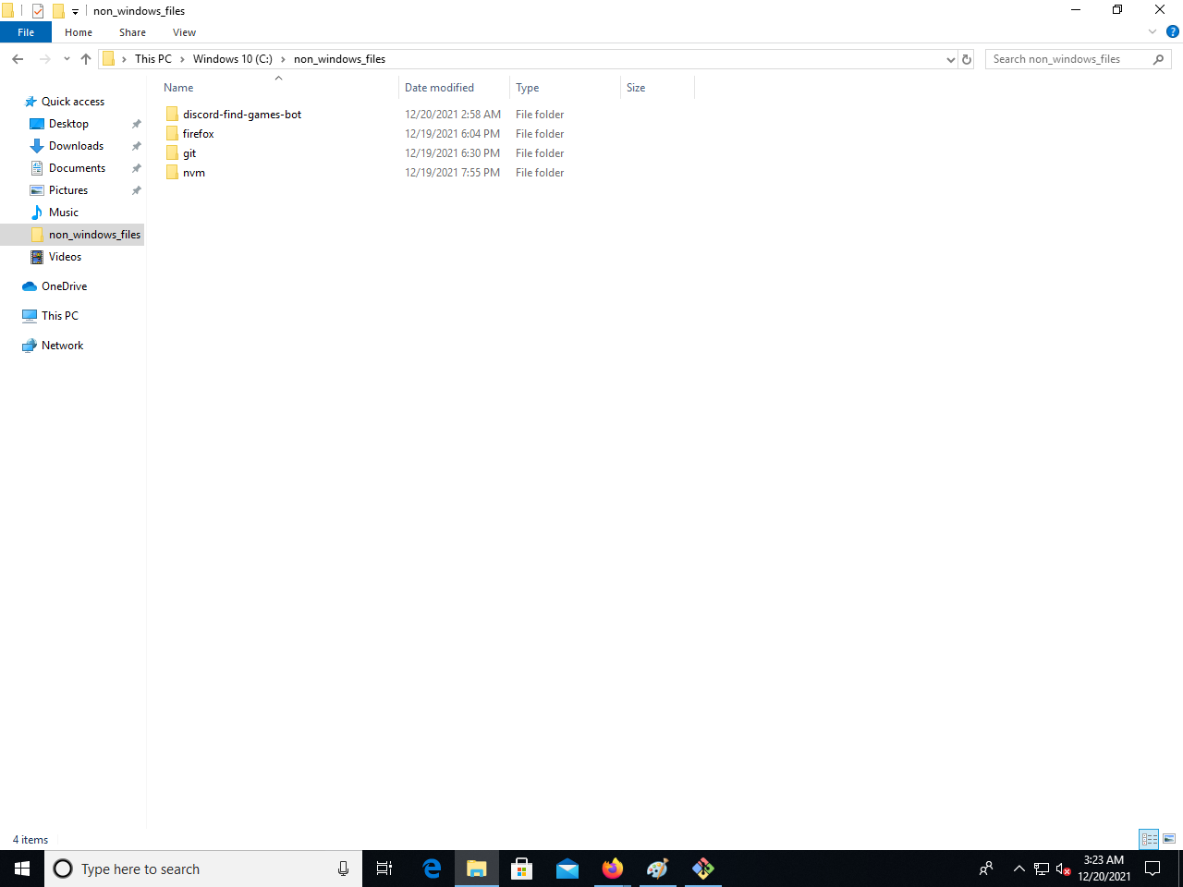  
  
Go in “discord-find-games-bot”  
  
You should see these files:  
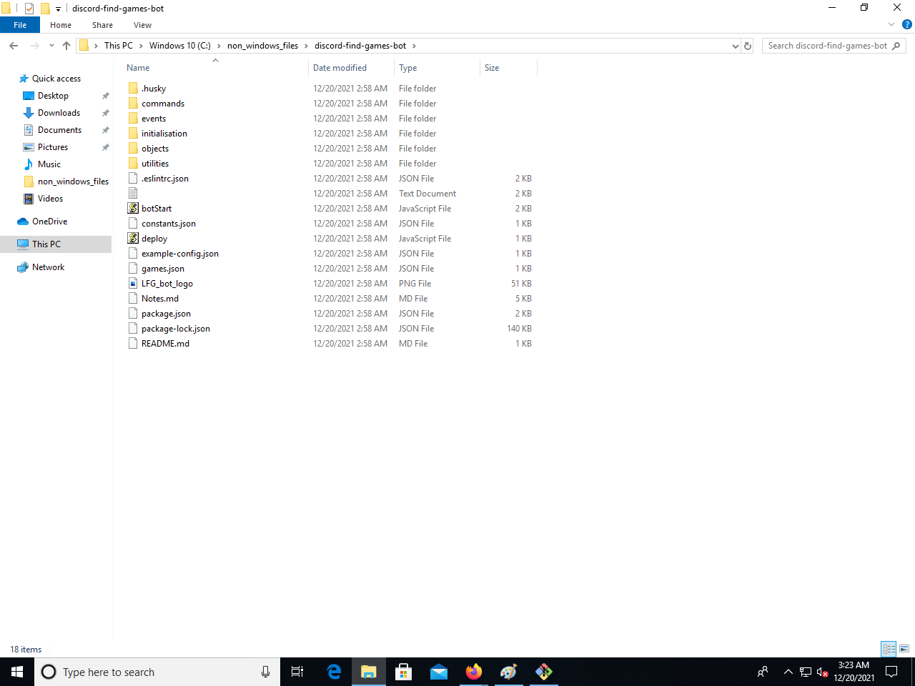  
Rename the file:  
“example-config.json” to “config.json” (if you see just “example-config  
don’t worry, it is the same file.  
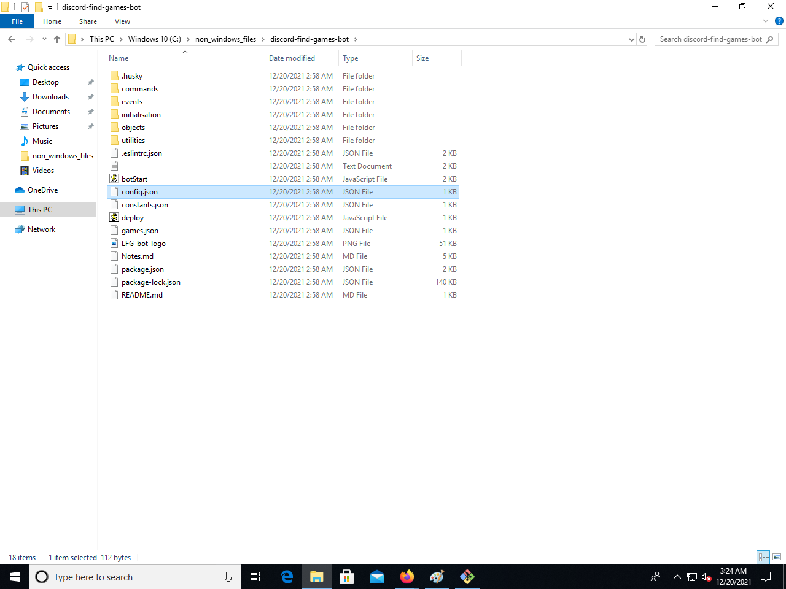

Right click and then “Open with”:

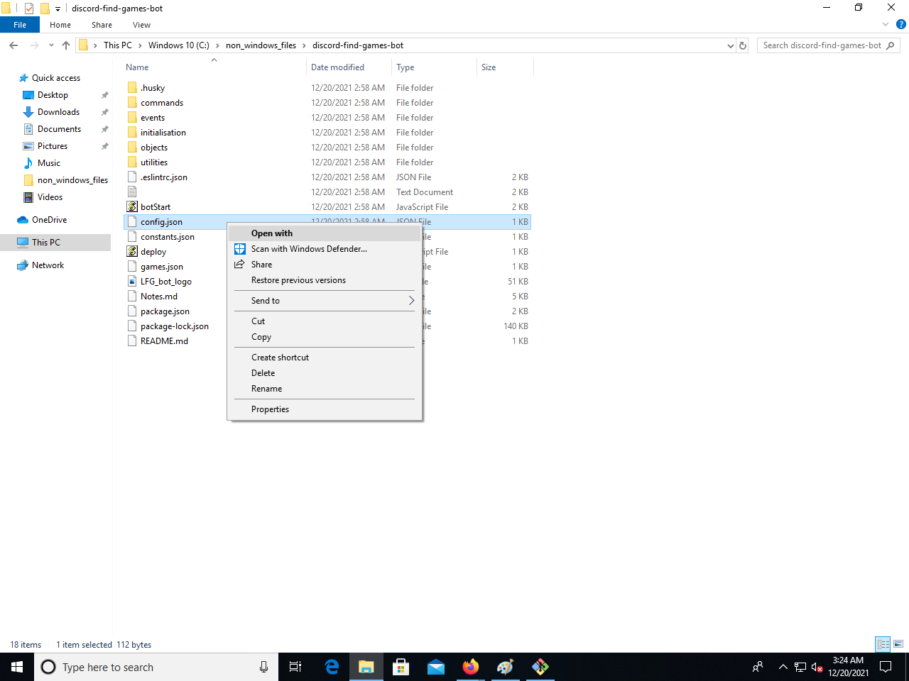

Click “More apps”:  
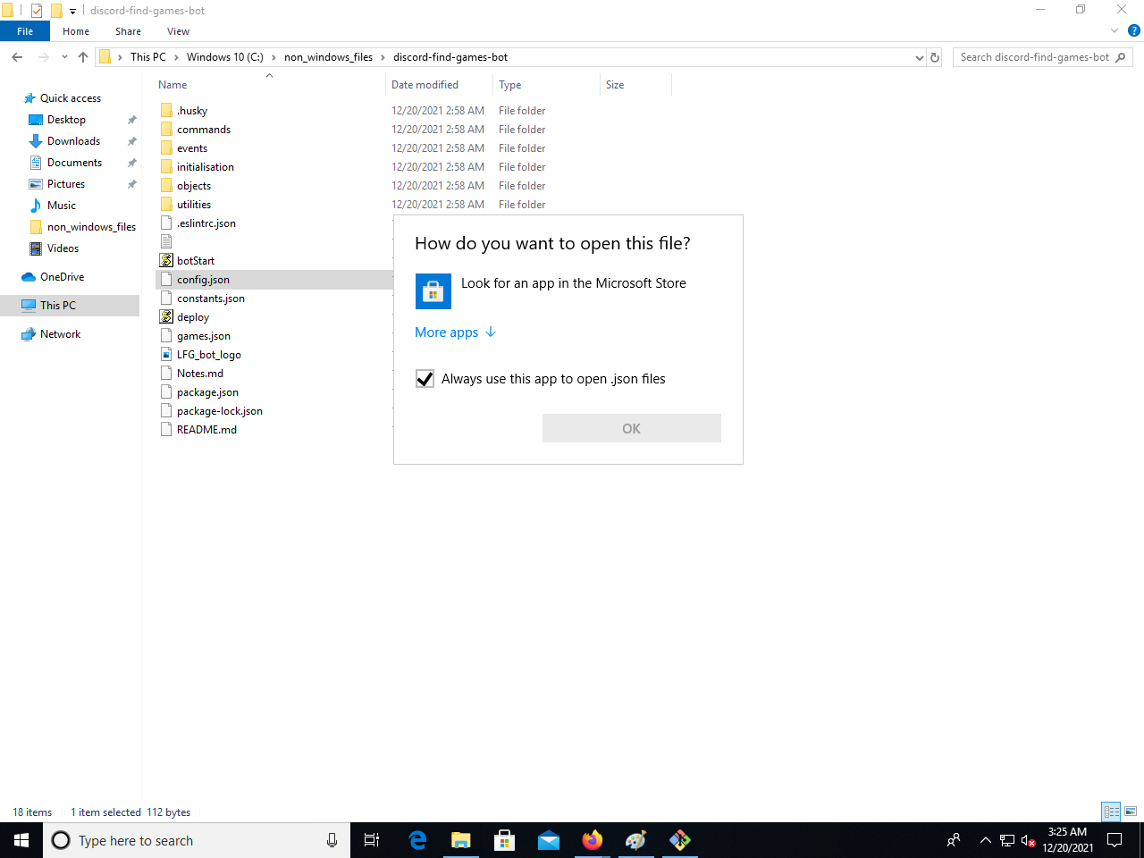

Open with Notepad:  
  
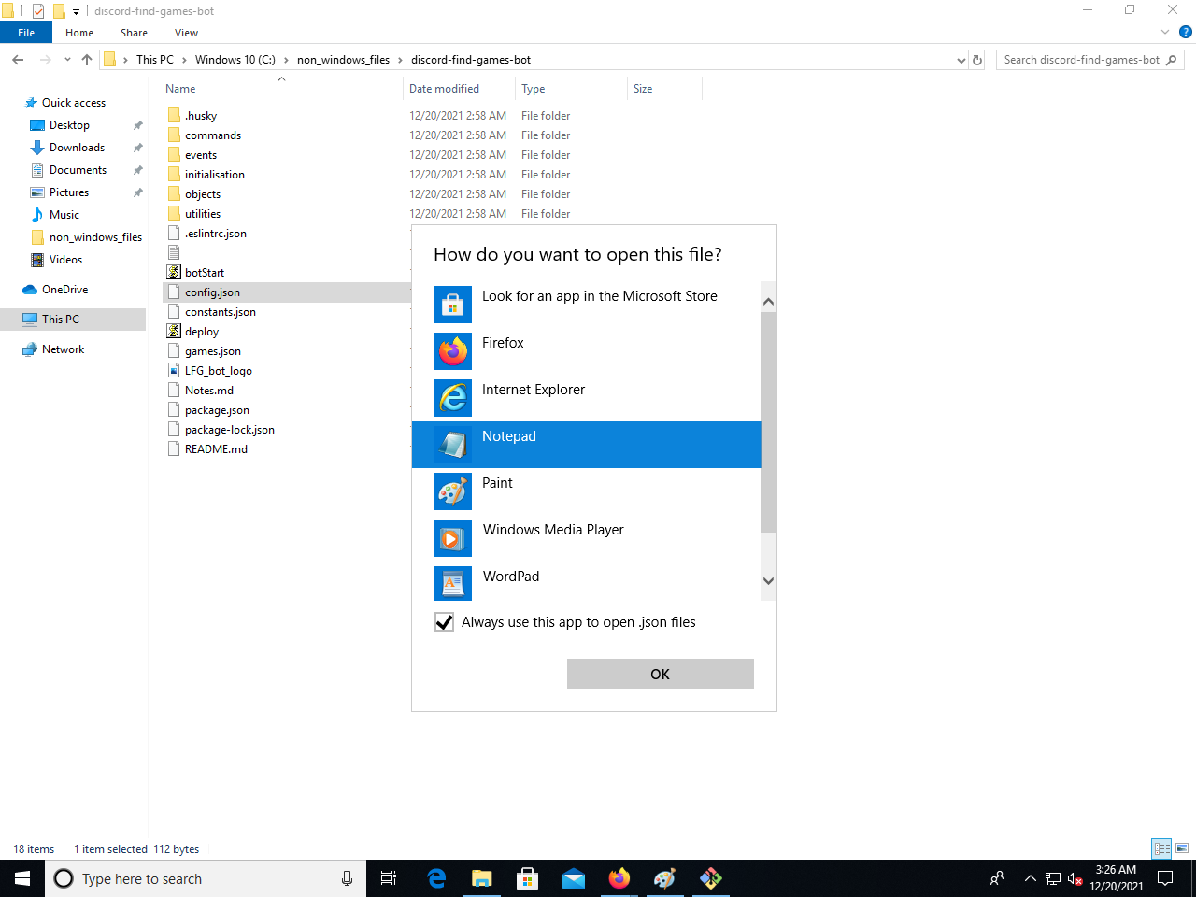

You should see:  
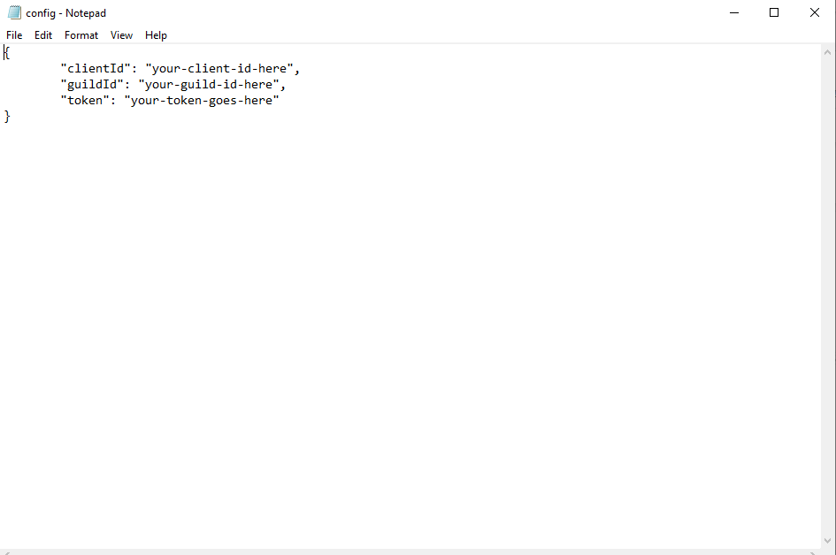  
  
Go back to the discord developer portal:  
Then go to “Ouath2”:  
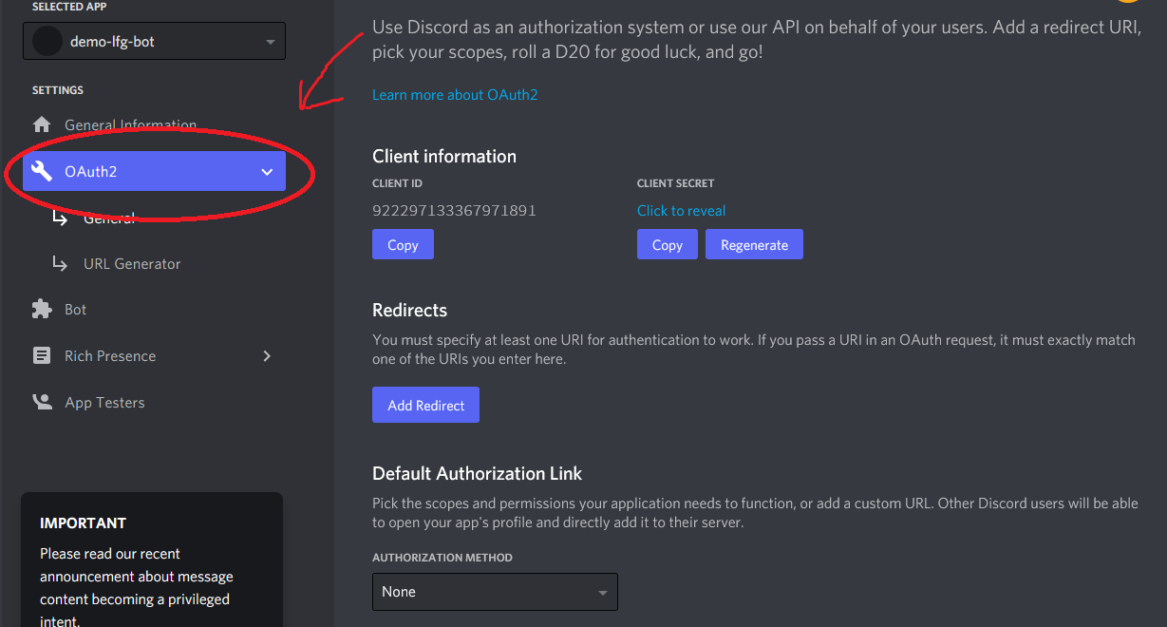

Copy “Client ID”

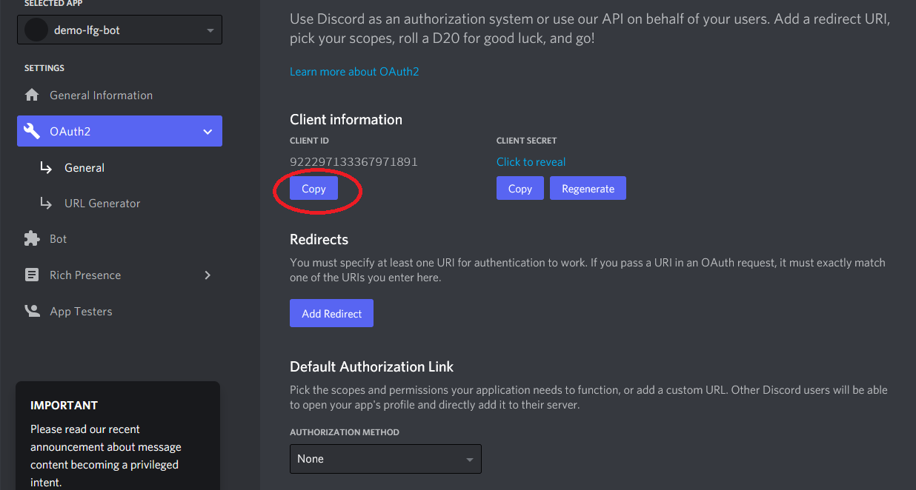

Paste it in:  
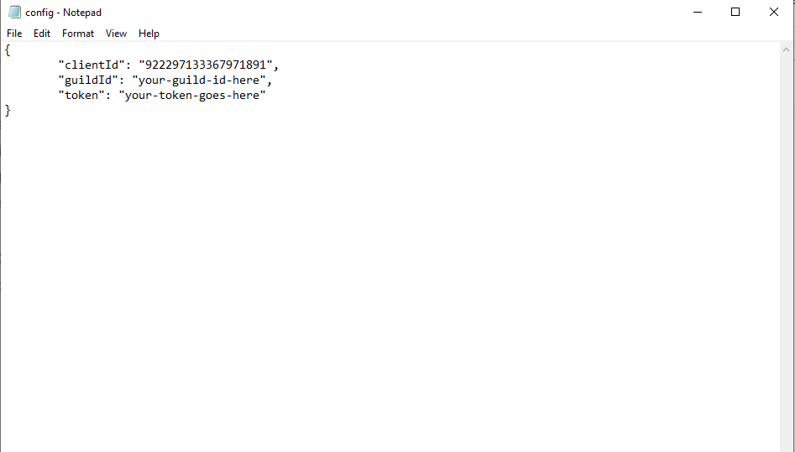

Copy the secret token:

Go to the “Bot” tab:  
  
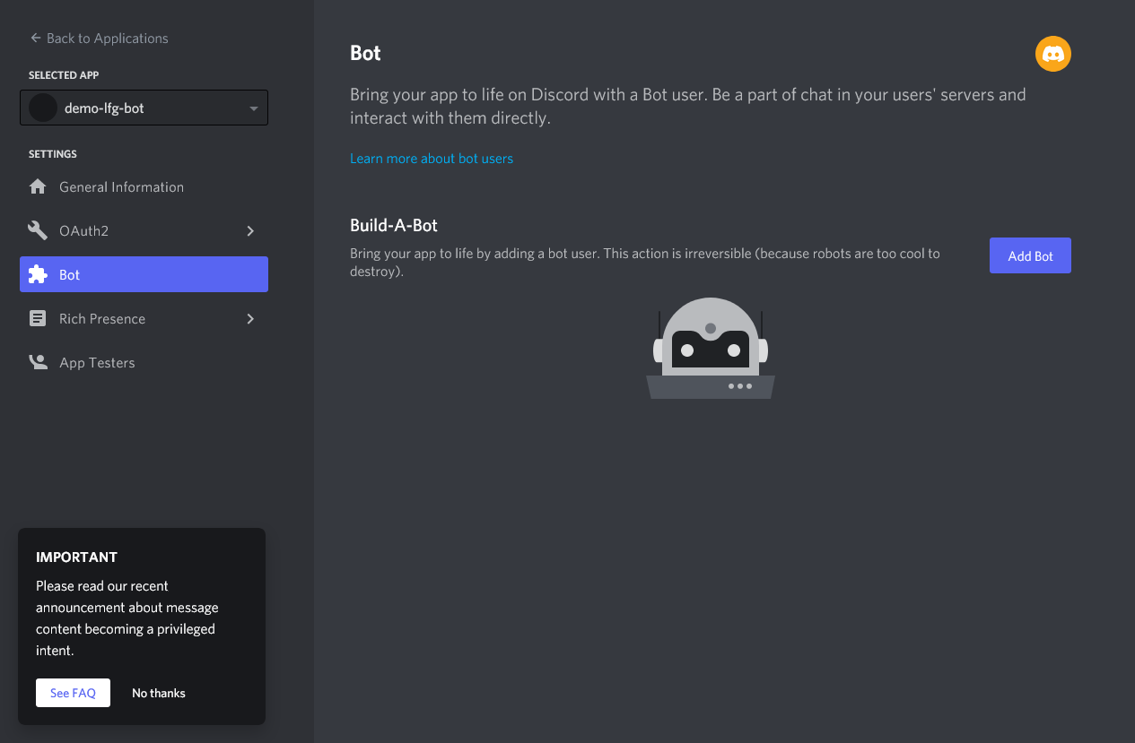

Click “Add Bot”:  
  
Copy the token:  
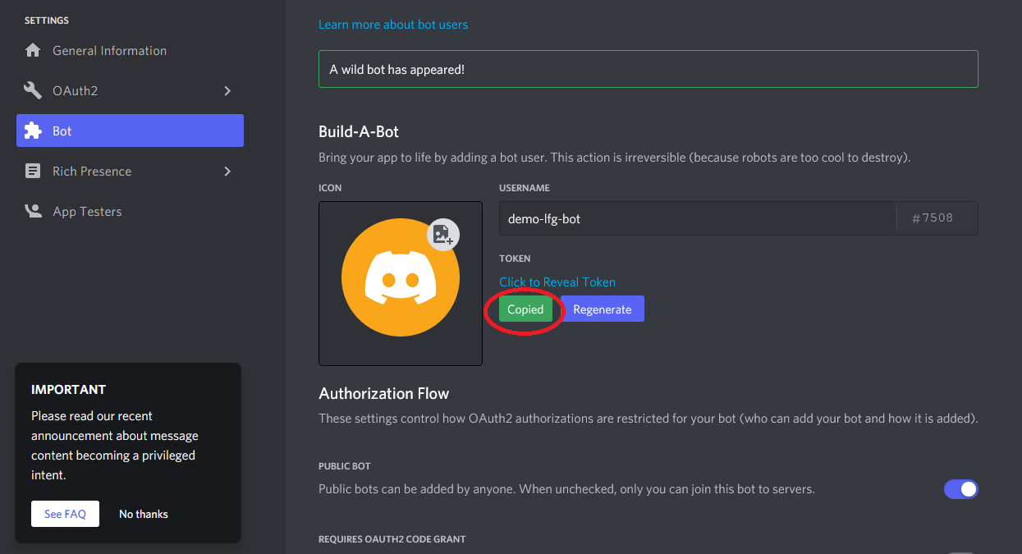

Paste it in:  
  
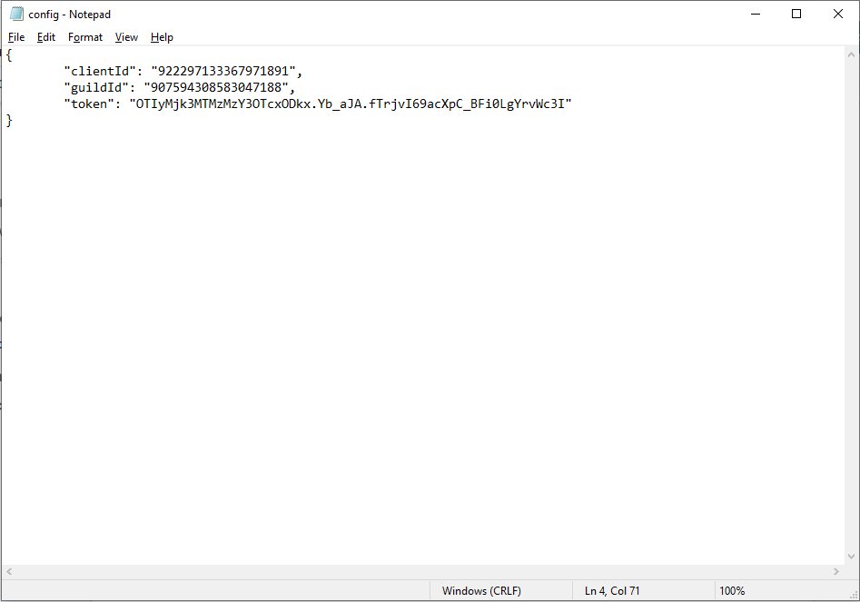

To get the “guildId”:  
  
Go to Discord, click the cog wheel (Blanked out menus and servers for privacy):  
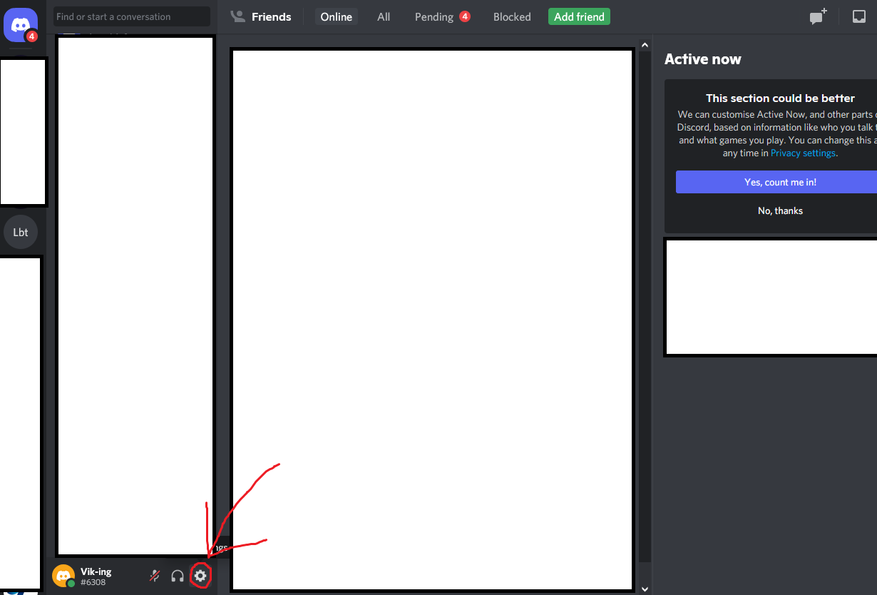

Go to the “Advanced tab”:  
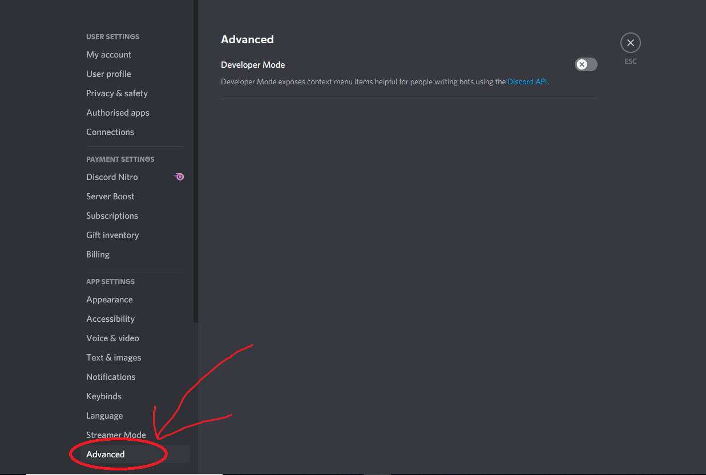

Enable “Developer Mode”:  
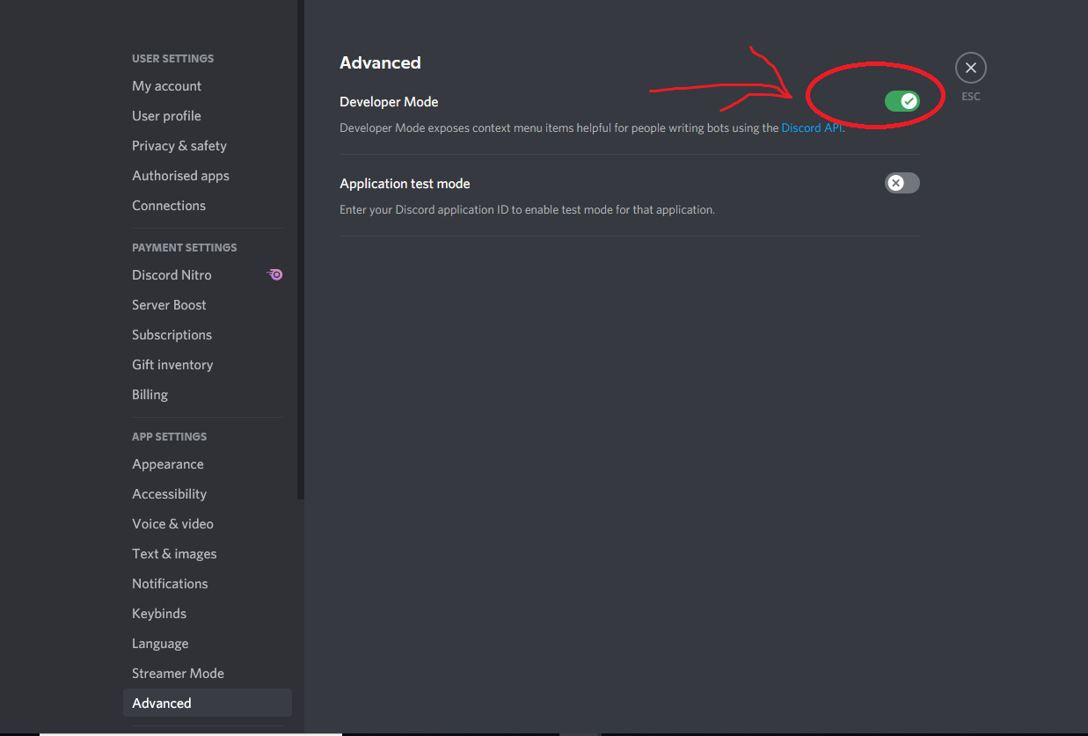

Right click the server in which you will use the bot and copy the ID (Blanked out menus and servers for privacy):  
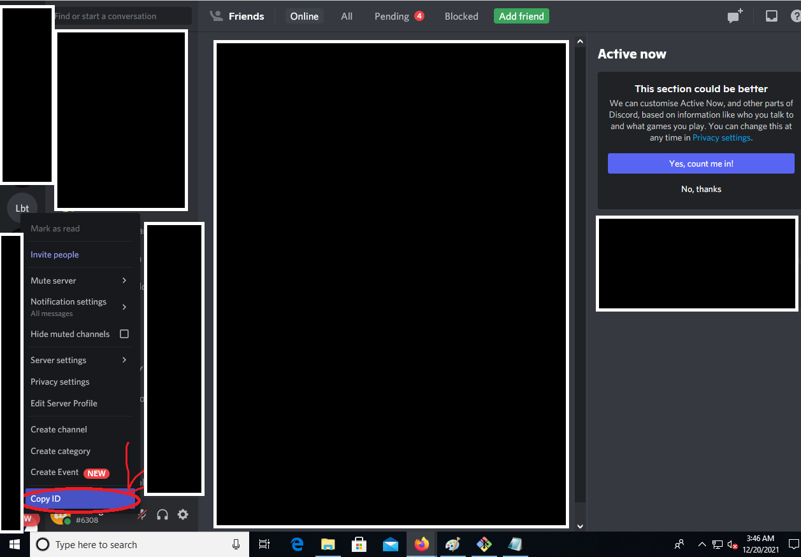

Paste in the “guildId”:  
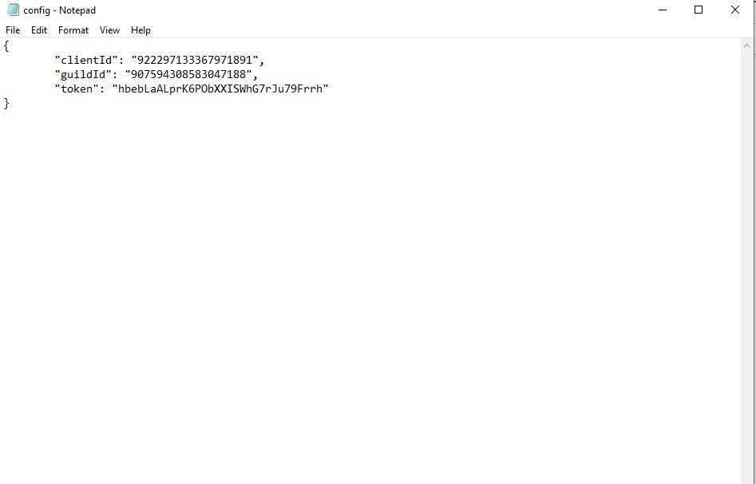

Save and close this file.  
  
  
In your Discord create a role that will have permissions to manage the bot and give it to yourself, the name does not matter. Go to the server and left click on yourself:

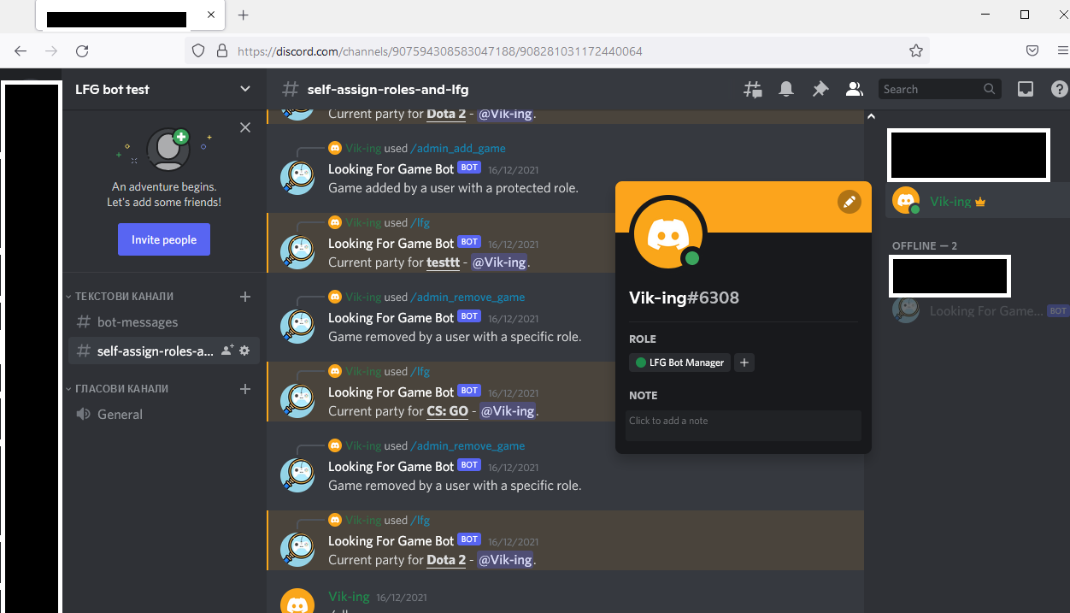  
  
Right click on the role you chose

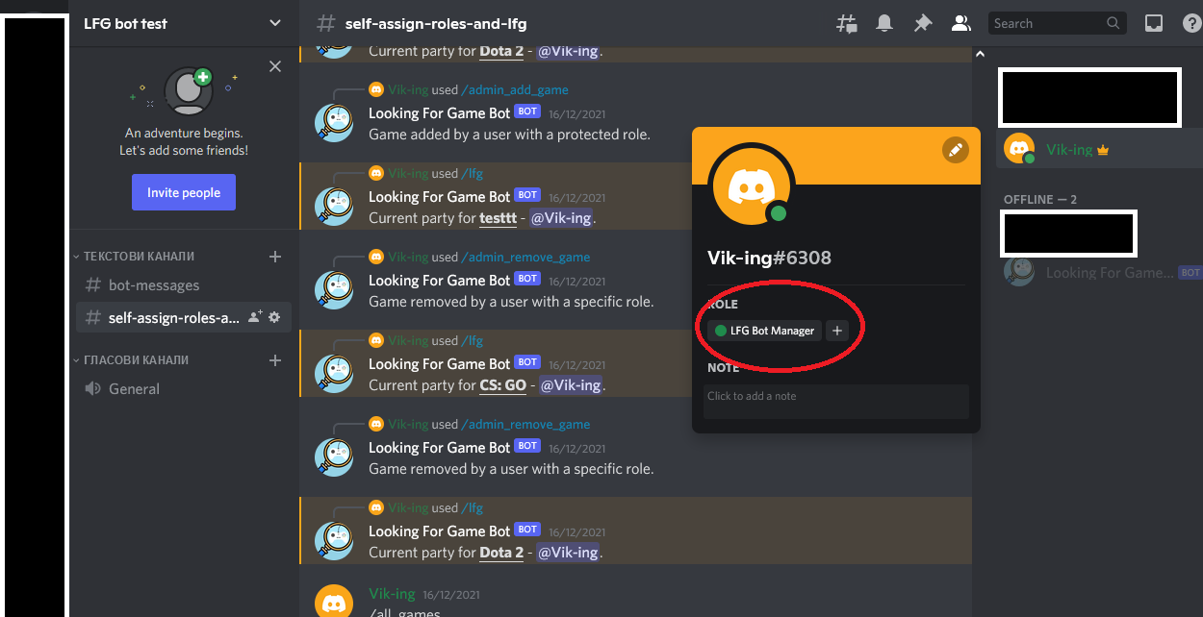

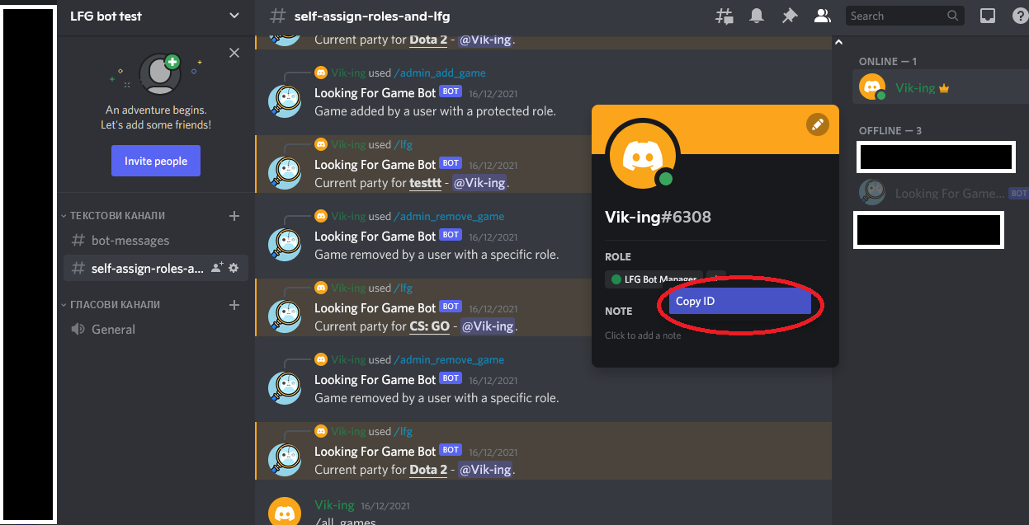

When you have the ID copied open the “constants.json” or just “constants” file (both are the same depending on if you see file extensions or not)  
  
You should see:  
  
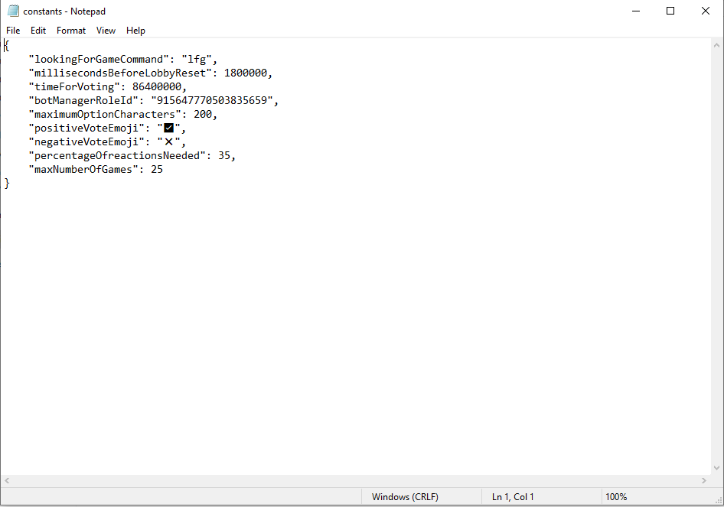  
  
Change "botManagerRoleId": "915647770503835659" to -   
"botManagerRoleId": "<the_id_you_just_copied>", that will allow everyone with the given role to add and remove games from the bot without needing to invoke a vote.

## Other values (an explanation):

"lookingForGameCommand": "lfg", - the command that people in the server need to invoke to start a lobby.

"millisecondsBeforeLobbyReset": 1800000, - the time before a lobby is disbanded (in milliseconds, each, this is 30 minutes).

"timeForVoting": 86400000, - time before a vote is disbanded, set to 24 hours

"botManagerRoleId": "915647770503835659",

"maximumOptionCharacters": 200, - the maximum characters a game name and “max_players” argument can have, don’t set it above 1000 because it can throw an error, related to max message size in discord

"positiveVoteEmoji": "✅", - emoji for positive vote

"negativeVoteEmoji": "❌", - emoji for negative vote

"percentageOfreactionsNeeded": 35, - percentage of people in the server that need to vote so a vote for the addition or removal of a game need to be resolved.

"maxNumberOfGames": 25 - the maximum number of games allowed, don’t set it above 25, there is a Discord limitation (at least in this version of the bot)

## Installing bot dependencies

Go to the bot folder (where you just edited files):  
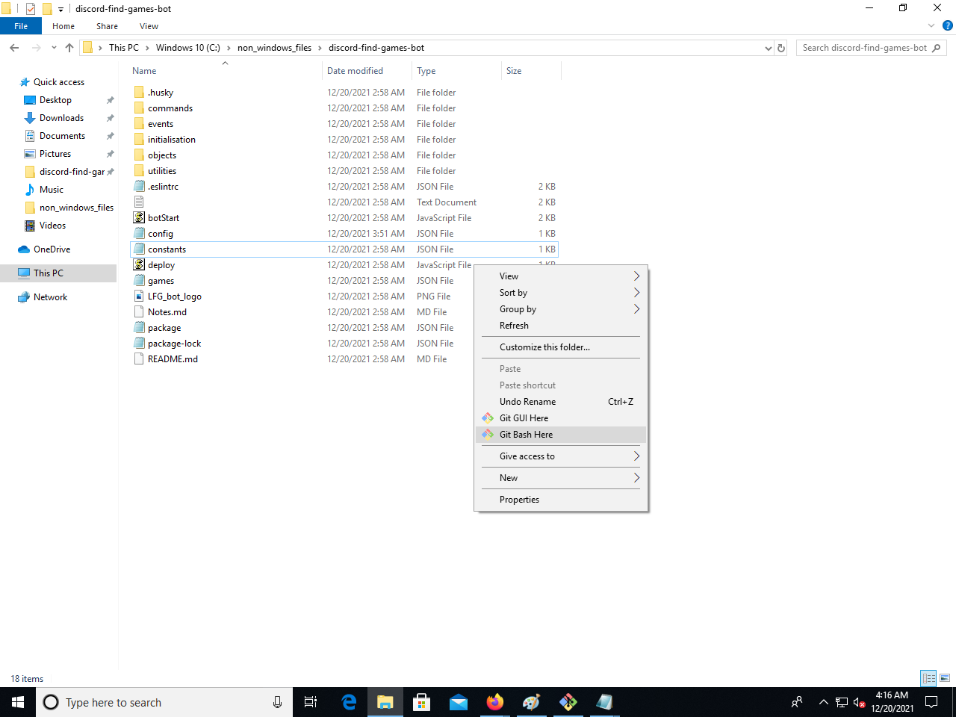  
  
Press, “Git Bash Here”:  
  
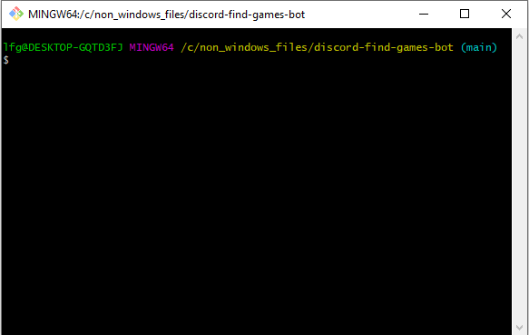

Type in “npm install”

You should see something like:  
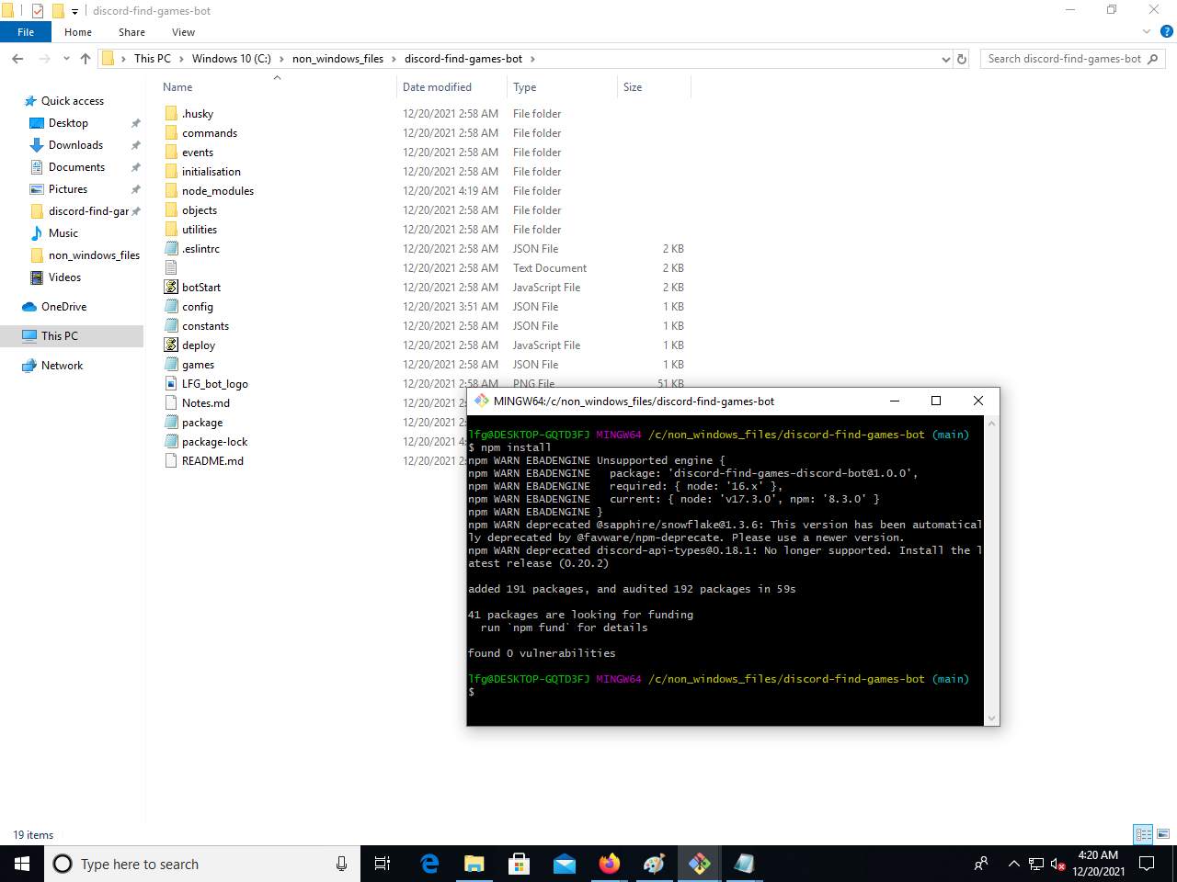  
And you should see a new folder called “node_modules”, keep this window open.

Creating an invite link and starting the bot:  
Go to the developer portal (from where we got the secret token):

<https://discord.com/developers/applications>  
  
  
Go to the “OAuth2” tab, then to “URL Generator”, check the “bot” and “application.commands” options:  
  
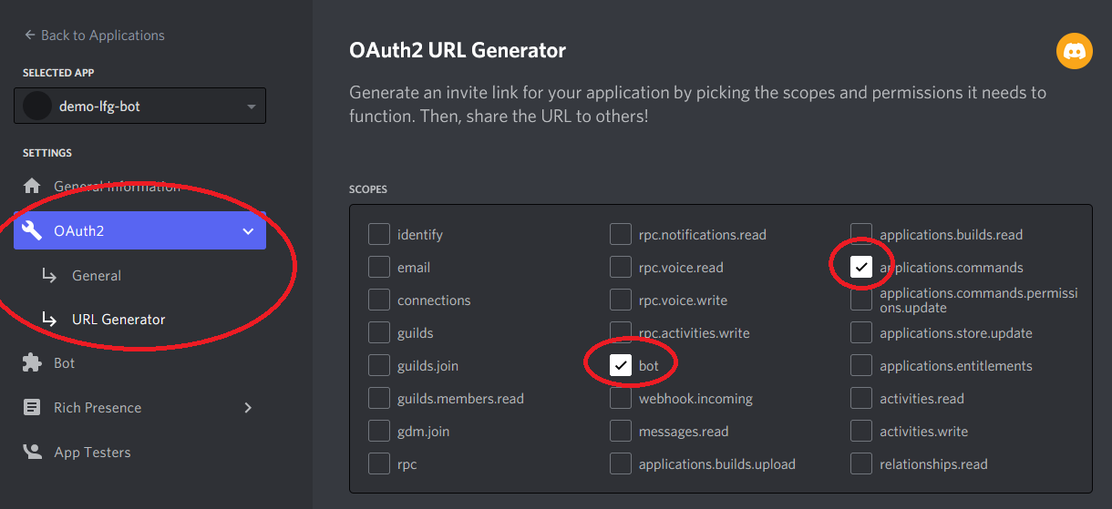

A “Bot Permissions” tab will appear below, check the following options:  
  
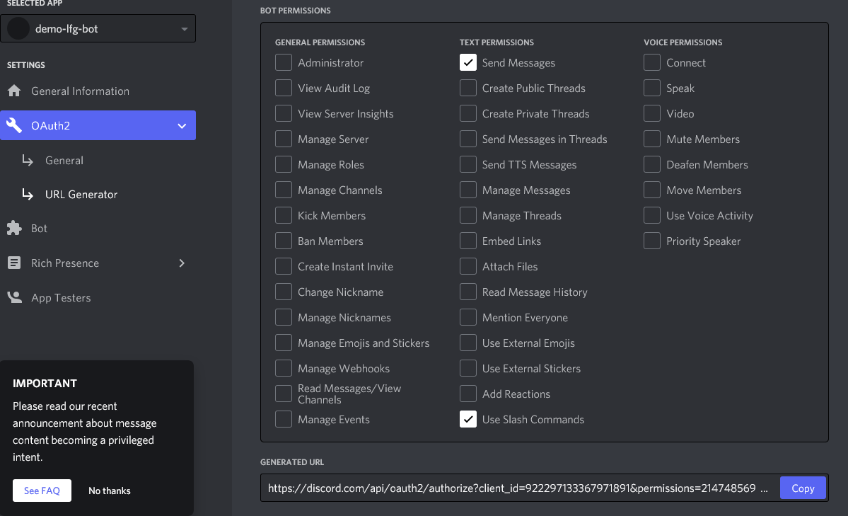

Copy the resulting URL:  
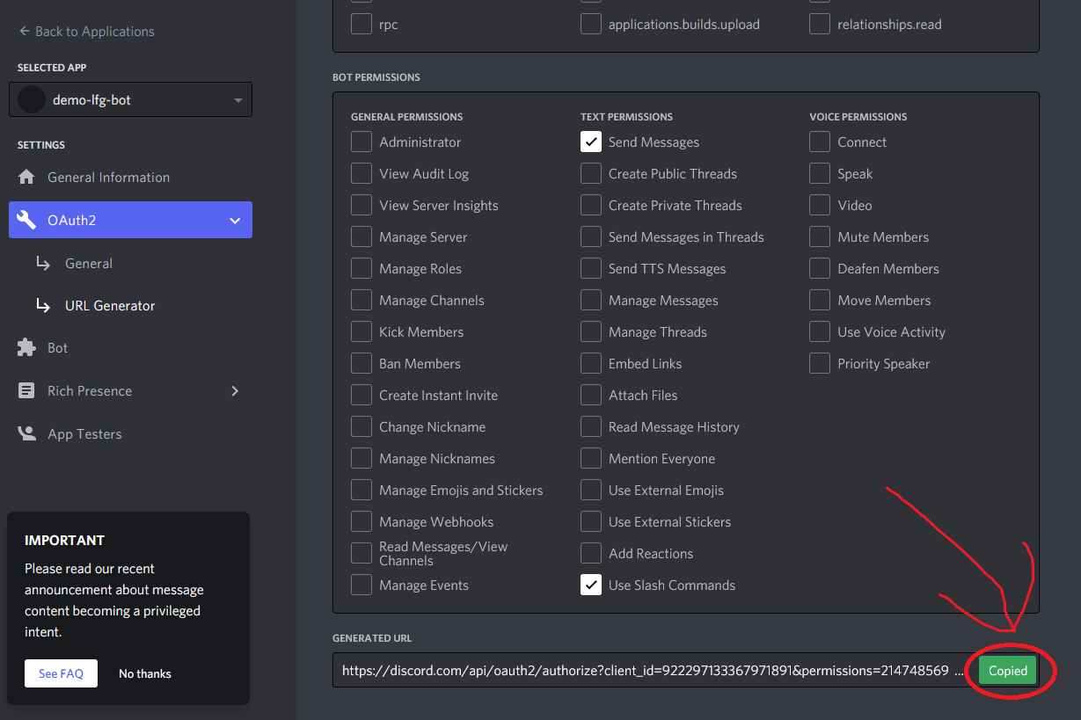

Paste it into your browser.  
  
Select the server you want to invite the bot to:  
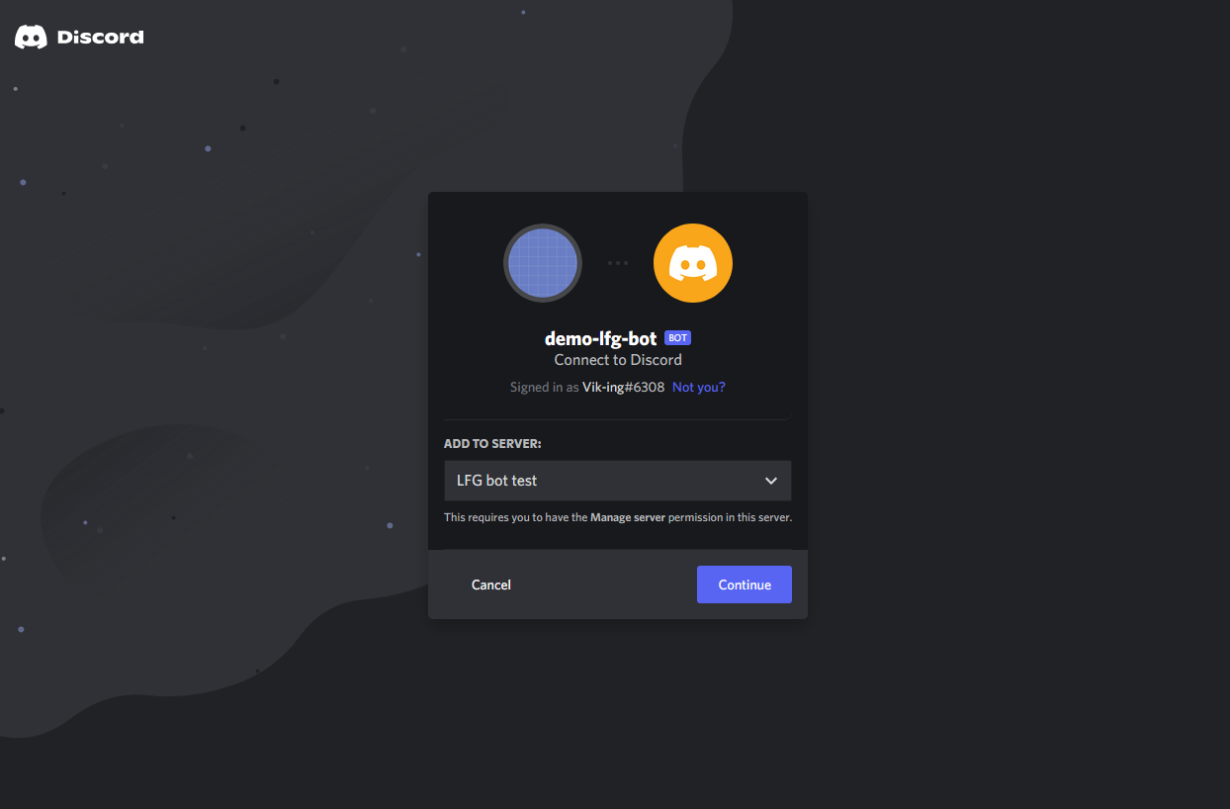

The bot should have only these permissions for its current version:  
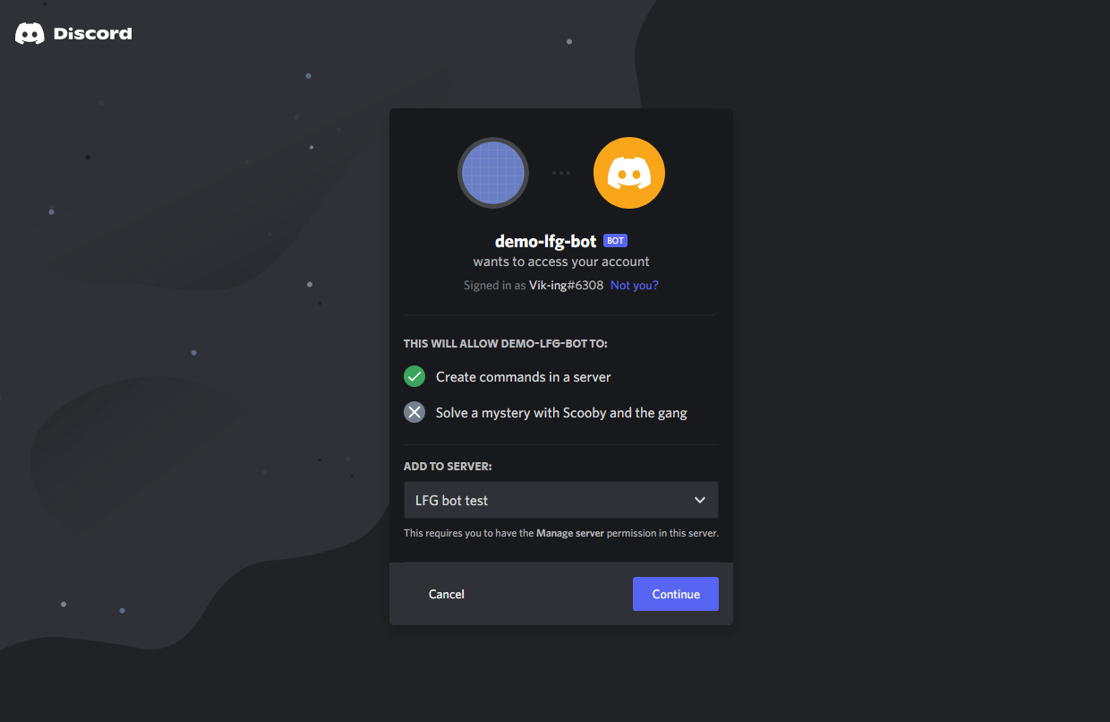  
If it has more or different ones, be cautious, especially if you don’t host it yourself.  
  
Now our robotic friend must be in the server:  
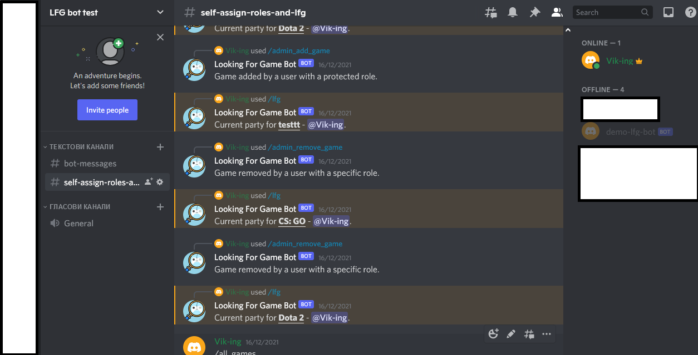

To activate it go back to the terminal (“Git Bash Here”, in the folder with the bot files):  
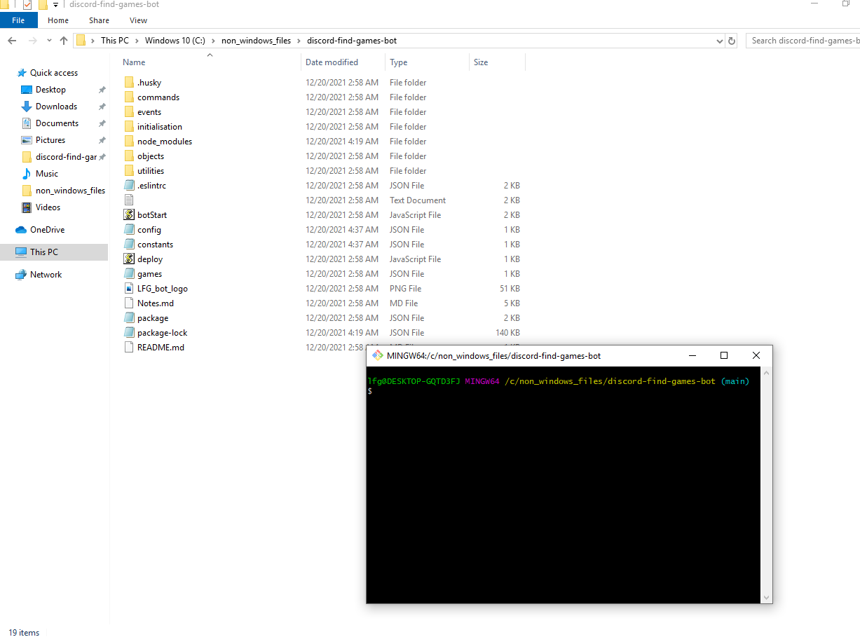  
  
Type in “npm run start”

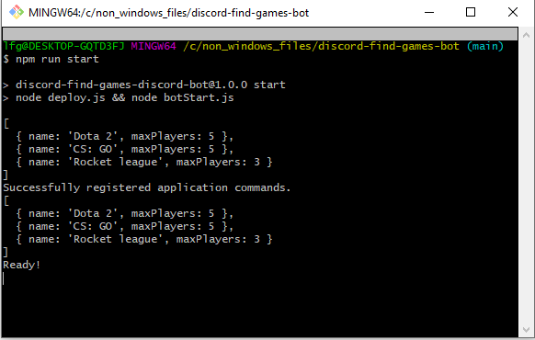  
  
Now, the bot is started, to turn it off press “ctrl + c”.

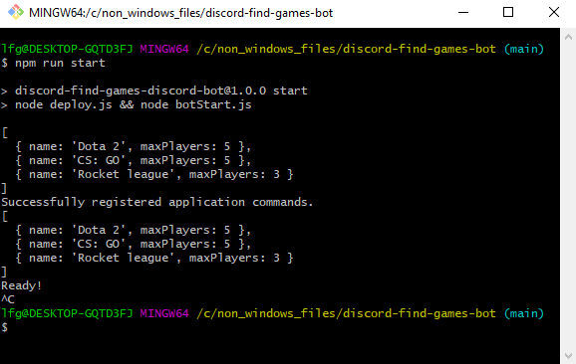

## Testing out the commands:

When you have the bot started:

/all_games

* Should yield:  
  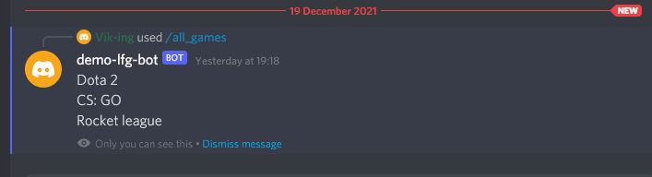

To add a game type in (only available to people with a given role):  
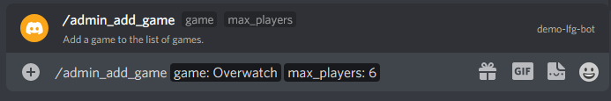  
  
  
Now when we type in “/lfg”, we have an option “Overwatch” which will make a lobby that resets when 6 people join or 24 hours pass.

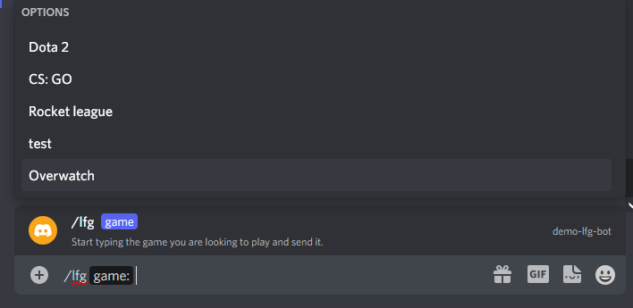

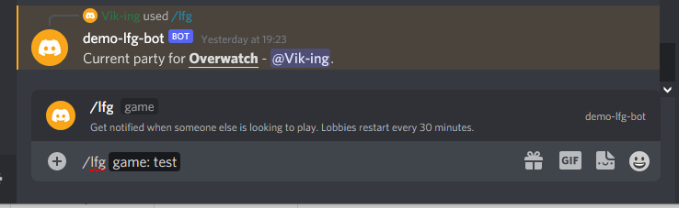

removing a game (as admin):

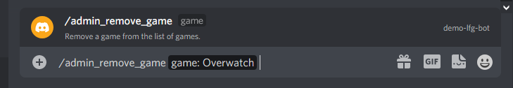

Now we don’t have “Overwatch” as an option:  
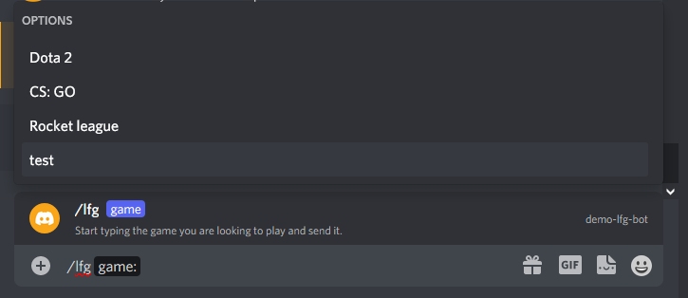  
  
A command suggesting a game for voting, by default 35% (the percentage can be changed from ‘constants.json’ of people in the server need to vote for it to be resolved.  
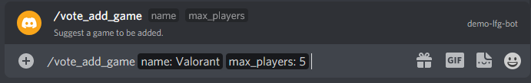

People can vote with reactions in the next 24 hours (this time can be changed) ‘constants.json’:  
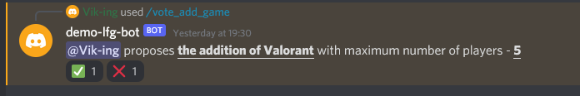

A vote to remove a game can be also be started:

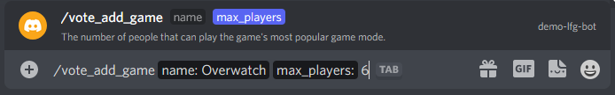

A vote resolved (because the server has very little people and just one vote resolves it):  
  
